

College of Business,

Technology and   
Engineering

MSc Dissertation Report

# “Mitigating Household Food Waste Using AI for Sustainable Consumption”

A dissertation submitted in partial fulfilment of the requirements of Sheffield Hallam University for the degree of Master of Science in

MSc Artificial intelligence

|  |  |
| --- | --- |
| Student Name | Danylo Krywyj |
| Student ID | c0010969 |
| Supervisor | Dr Jing Wang |
| Date of submission | 5th September 2024 |

This dissertation does NOT contain confidential material and thus   
can be made available to staff and students via the library.

## Abstract

This dissertation research project explores how AI can mitigate household food waste by detecting expiration dates on food packaging. This issue was examined due to the significant contribution of household food waste to environmental degradation, with current methods lacking automation and precision. Existing research suggests that household food waste stems from inefficiencies in managing expiration dates, but little research has been done on the role of AI in this area. To better understand the potential of AI-driven solutions, the YOLO (You Only Look Once) models were employed for expiration date detection using a dataset of real-world images captured under various conditions. Additionally, a public opinion questionnaire was conducted to assess awareness of food waste issues, the perceived need for AI solutions, and concerns around adoption, effectiveness, and privacy.

The findings from this research demonstrated that both YOLOv5 and YOLOv8 models were effective at detecting expiration dates, with YOLOv8 showing slightly higher accuracy. However, challenges such as dataset diversity and the integration of Optical Character Recognition (OCR) remain to be addressed. The questionnaire results provided valuable insights into user perceptions, highlighting the potential for widespread adoption, but also emphasising concerns about data privacy.

Based on these results, this dissertation concludes that AI-driven expiration date detection systems can significantly reduce household food waste. Nevertheless, future work is needed to enhance accuracy, integrate OCR for improved text recognition, and address concerns related to privacy and data security. Expanding the dataset and refining model performance could further optimise the system’s impact on sustainable consumption.

## Acknowledgements

I would like to express my deepest gratitude to all the lecturers from the MSc Artificial Intelligence course at Sheffield Hallam University, whose guidance and expertise have been instrumental throughout my academic journey. I am very thankful to my supervisor, Dr. Jing Wang, whose unwavering support, insightful feedback, and encouragement have been invaluable during my dissertation. His expertise and willingness to provide thoughtful guidance helped shape my research and provided clarity during challenging times.

Additionally, I would like to extend my thanks to the wider faculty for their dedication and commitment to teaching, which greatly enhanced my understanding of the diverse and complex fields within artificial intelligence. The knowledge and skills I gained from their lectures, workshops, and discussions were crucial in the successful completion of this project.

Finally, I would also like to acknowledge my family and friends for their continued support, patience, and motivation throughout this demanding process. Their belief in me has been a constant source of strength, and I am incredibly thankful for their encouragement and understanding during the more difficult moments.

## Contents

“Mitigating Household Food Waste Using AI for Sustainable Consumption” 1

Abstract 2

Acknowledgements 2

1.0 Introduction and Justification 5

1.1 Research question 6

1.2 Aims 6

1.3 Objectives 6

1.4 Deliverable 7

1.5 Rationale and Overview 7

2.0 Literature review 7

2.1 Motivations for Addressing Household Food Waste & Exploring Key Drivers 7

2.2 Bridging Behavioural Change and Technology in Household Food Waste Management 8

2.3 Theoretical Frameworks in AI-based Food Management 9

2.4 Comparative Analysis of YOLO Variants 11

2.5 Challenges in AI-based Expiration Date Detection 12

2.6 Summary of Literature Review 13

3.0 Research Design, Methodology, and Tools 14

3.1 Research Philosophy and Approach 14

3.2 Data Collection Techniques 14

3.3 Data Preprocessing and Model Training 15

3.4 Justification for YOLO Model Selection and Training Techniques 16

3.5 Integration with OCR Technology 17

3.6 Visualisation and Analysis Tools 17

3.7 Computational Resources 17

4.6 Alternative Tools and Techniques Considered 18

5.0 Ethics, Risks, and Issues 18

5.1 Ethical Considerations 18

5.2 Potential Risks and Mitigation Strategies 20

6.0 Results and Discussion: 20

YOLOv5 & YOLOv8 20

6.1 Algorithm Performance: YOLOv5 and YOLOv8 21

6.2 Detailed Visual Examples of Expiration Date Detection 22

6.3 Implications for Food Waste Reduction 22

6.4 Limitations and Areas for Improvement 22

6.5 Future Directions 23

6.3 YOLOv5 and YOLOv8 Results: Performance Metrics and Model Analysis 24

6.4 Optical Character Recognition (OCR) Integration and Results 49

6.5 Implications and Future Directions 49

7.0 User Evaluation and Feedback 50

Survey Section for Dissertation 50

Public Opinion Survey on AI-Driven Solutions for Reducing Household Food Waste 50

Purpose of the Survey 50

7.1 Survey Methodology 50

7.1.1 Research Design 50

7.1.2 Survey Instrument 50

7.1.3 Sample and Sampling Method 51

7.1.4 Data Collection Procedure 51

7.1.5 Ethical Considerations 51

7.2 Analysis of Survey Feedback 52

8.0 Conclusion and Recommendations 54

8.1 Summary of Findings 54

8.2 Recommendations for Future Research 55

8.3 Final Reflections 55

9.0 References 56

10.0 Appendices 59

Appendix A: Research Project Plan 60

1. Introduction and Justification 60

2. Research Question 60

3. Aims 60

4. Objectives 60

5. Deliverables 60

6. Literature Review Summary 60

7. Research Methodology 61

8. Timeline 61

9. Ethical Considerations 61

10. Risks and Mitigation Strategies 61

11. Conclusion 61

Appendix B: Research Ethics Approval 62

Appendix C: Participant Consent Form 69

Appendix D: Survey Questionnaire 70

Appendix E: Survey Feedback and Public Survey Results 75

Appendix F: Annotated Code Snippets 81

Appendix G: Detailed YOLO V5 Model Performance Data 87

Appendix H: Detailed YOLO V8 Model Performance Data 97

## Table of figures

Figure 1 Gantt Chart 18

Figure 2 Yolo v5 prediction 21

Figure 3 Yolo v5 prediction 2 21

Figure 4 Yolov8 label prediction 22

Figure 5 Yolo v8 label prediction 2 22

Figure 6 Household waste in a year 25

Figure 7 Likelihood of adopting AI App 27

## 1.0 Introduction and Justification

Household food waste represents 47% of total food waste in the EU, significantly contributing to greenhouse gas emissions and resource depletion. Globally, around one-third of food produced is wasted, valued at up to $2.6 trillion when including environmental and social costs. In the UK alone, households generate 7.3 million tonnes of food waste annually, with potential economic savings of £338 million if optimal waste treatment strategies are implemented. Reducing food waste by just 2% could save 480,000 tonnes of CO2 equivalent annually, underscoring the importance of effective waste prevention strategies to mitigate economic and environmental impacts.

The proposed AI-driven solution leverages YOLO (You Only Look Once) models to manage food items based on their expiration dates. By utilising a dataset of real images of expiration dates captured under various challenging conditions, the system is designed to accurately detect and classify these dates. This automation minimises the need for manual input, ensuring precise tracking of food items and promoting sustainable consumption practices.

This approach not only aids in reducing food waste but also supports healthier eating habits by encouraging timely consumption of products. The successful implementation of these models could lead to the development of automated systems in retail or household settings, ensuring that expired products are efficiently flagged for removal, thereby enhancing food safety and contributing to more sustainable living.

### 1.1 Research question

How can YOLO models enhance the accuracy of expiration date classification to reduce food waste?

### 1.2 Aims

This project aims to develop an AI-driven system leveraging YOLO models and expiration date data to reduce household food waste. The system will accurately detect and classify expiration dates on food packaging, using the ExpDate dataset. By automating the identification and tracking of these dates, the system will minimise waste, promote timely consumption, and support sustainable and healthier eating habits. The project's effectiveness will be assessed through model performance metrics and its potential impact on food management practices, with the goal of enhancing food tracking and encouraging widespread adoption.

### 1.3 Objectives

* **Expiration Date Detection**: Implement and evaluate YOLO models to accurately detect and classify expiration dates from images of food packaging using the ExpDate dataset.
* **Dataset Utilisation**: Leverage the ExpDate dataset to test the YOLO models under various challenging conditions, ensuring robust and accurate expiration date detection.
* **Promoting Sustainable Consumption**: Explore the potential impact of accurate expiration date detection in reducing food waste and promoting sustainable consumption practices.
* **Model Performance Evaluation**: Assess the performance of the YOLO models using metrics such as precision, recall, and mAP (mean Average Precision) to determine their effectiveness in expiration date detection tasks.
* **Questionnaire Analysis**: Conduct and analyse a questionnaire to gather user perceptions, feedback, and insights regarding the effectiveness and potential real-world application of expiration date detection using AI models.

### 1.4 Deliverable

The project's deliverable is a prototype AI-driven system that utilises YOLO models to accurately detect and classify expiration dates from food packaging images. By leveraging the ExpDate dataset, the system aims to enhance the accuracy of expiration date detection under various challenging conditions. The primary focus is on evaluating the effectiveness of these models in minimising household food waste and promoting sustainable consumption. The project will also include an analysis of user perceptions and feedback through a questionnaire, aiming to understand the potential real-world impact of such technology on food management practices.

### 1.5 Rationale and Overview

This dissertation stems from the urgent need to address the global issue of household food waste, which contributes significantly to environmental degradation and economic loss. The scale of the problem, particularly in the UK and the EU, where millions of tonnes of food are wasted annually, highlights the importance of developing innovative solutions. Inspired by these challenges, this project leverages advanced AI technologies, specifically YOLO models, to enhance the accuracy of expiration date detection on food packaging. By automating this process, the system aims to reduce food waste, promote healthier consumption habits, and contribute to sustainable living. The project's core objectives are centred on testing the YOLO models under real-world conditions, using the ExpDate dataset, and evaluating their performance through key metrics such as precision, recall, and mAP. Additionally, the inclusion of user feedback through questionnaires will provide valuable insights into the practical applications and public perception of AI-based food management systems. The final deliverable is a prototype system designed to streamline food tracking and reduce waste, with the potential to influence both household practices and broader industry adoption. Through this research, the project aims to contribute to ongoing efforts in sustainable consumption and food waste reduction, while offering a foundation for future AI-driven innovations in this field.

## 2.0 Literature review

### 2.1 Motivations for Addressing Household Food Waste & Exploring Key Drivers

Household food waste has become a significant contributor to global food loss, exacerbating both environmental degradation and economic inefficiencies. This issue, largely driven by consumer behaviours and misunderstandings related to food management, particularly expiration dates, presents a critical area for technological intervention. Given the importance of addressing expiration dates in reducing food waste, this research specifically explores how AI models, namely YOLO, can enhance expiration date detection, aligning with the overall goal of minimising household food waste. Understanding the key drivers behind household food waste is essential in framing the role of AI solutions in mitigating this problem.

Several studies offer valuable insights into the motivations and barriers linked to household food waste, underscoring the need for AI-based solutions. Nunkoo et al. (2020) identified that although consumers often experience guilt over wasted food, their awareness of the broader environmental consequences remains limited. This creates a gap where AI systems, such as the one proposed in this research, can play a vital role by improving expiration date management and thereby reducing waste frequency. This directly relates to the objective of this dissertation, which seeks to implement YOLO models for more efficient and cost-effective food consumption through accurate expiration date identification and classification.

Stangherlin and de Barcellos (2018) further highlight the significant role of financial considerations, noting that households, particularly those with lower incomes, are more likely to adopt behaviours aimed at reducing waste when they perceive a direct economic benefit. The AI system proposed here aligns with this motivation by offering real-time tracking of food expiration dates, thereby reducing premature disposal. This promotes more effective stock management, contributing directly to the sustainable consumption practices that form a key aim of this research.

Moreover, cultural, and social norms also play a critical role in shaping food waste behaviours, as described by Stangherlin and de Barcellos (2018). In many cultures, food abundance and hospitality lead to over-purchasing and excess preparation, which in turn results in higher levels of waste. By offering accurate expiration date detection and reminders, AI-driven solutions developed in this dissertation can help consumers make more informed decisions about food purchasing and usage, aligning these decisions with broader sustainability goals.

The barriers to reducing household food waste are multifaceted, yet technology, particularly AI, has a significant role to play in overcoming them. Nunkoo et al. (2020) point out that a lack of infrastructure, coupled with inadequate policy support, limits the effectiveness of waste reduction initiatives. The AI solution proposed in this dissertation addresses this gap by offering a readily accessible, user-friendly system that can be seamlessly integrated into everyday life, reducing the need for external infrastructure. By empowering consumers to take control of their food management practices, this research aligns with the objective of leveraging the ExpDate dataset for robust expiration date detection, a core part of the dissertation’s aims.

In conclusion, the insights gained from these studies directly inform the development of the proposed AI-driven solution. By targeting the key drivers of household food waste—consumer attitudes, economic concerns, and cultural practices—this research positions the YOLO-based system as a practical tool to promote both financial savings and environmental sustainability. Additionally, by tackling the specific challenge of expiration date detection, this system aims to shift consumer behaviour towards more mindful food consumption, further supporting the goal of sustainable living.

### 2.2 Bridging Behavioural Change and Technology in Household Food Waste Management

Building on the key drivers of household food waste explored in the previous section, it is essential to examine the role of consumer behaviour in shaping food management practices. As outlined by Principato et al. (2021), poor practices such as over-purchasing, improper storage, and confusion over expiration dates significantly contribute to food waste. The Household Wasteful Behaviour Framework identifies several behavioural and socio-economic factors, including lack of meal planning, impulse buying, and misinterpretation of food labels. These factors are directly linked to household waste and align with the overarching goal of this research, which seeks to improve expiration date detection through AI-driven solutions, such as YOLO models, to mitigate these behaviours.

Technologies such as the Kitche app illustrate how AI-based systems can effectively support behavioural change by tracking food inventory, offering reminders about expiration dates, and providing meal planning tips. Kitche enables users to scan grocery receipts, create a digital inventory of food, and receive real-time alerts for expiring items. By suggesting recipes based on available ingredients, Kitche not only addresses food mismanagement but also promotes better consumption practices. Although these features offer significant benefits, Principato et al. (2021) argue that tools such as Kitche must be integrated with broader behavioural interventions to address deeper consumer habits, such as improving food literacy and shifting social norms. This observation is particularly relevant to this research, which aims to develop an AI system that not only enhances expiration date detection but also integrates seamlessly into everyday household food management to promote sustainable consumption.

Another example of technology addressing food waste is the platform Too Good To Go, which connects consumers with restaurants and retailers offering surplus food at discounted prices. In 2023, it saved over 121 million meals, reducing 328,554 tonnes of CO2e emissions and conserving 100 billion litres of water. The platform’s Look-Smell-Taste campaign educates consumers on how to assess food quality before discarding it, helping address confusion over expiration dates. This emphasis on consumer education complements the technological intervention by improving understanding, which directly aligns with this project's goal of fostering sustainable consumption habits through the use of AI-powered expiration date detection.

Educational campaigns and broader public awareness initiatives play a crucial role in shifting consumer behaviour towards more sustainable practices. When combined with AI-driven applications such as Kitche or platforms like Too Good To Go, these initiatives offer a multi-faceted approach to reducing unnecessary waste. The integration of real-time AI feedback with broader consumer education creates a comprehensive solution, directly supporting the objective of reducing household food waste through improved expiration date detection and food management practices. This also reinforces the potential of YOLO models, which can provide accurate expiration date classification, aligning with the core aims of this dissertation.

While AI systems such as Kitche and platforms such as Too Good To Go provide valuable technological solutions, Principato et al. (2021) stress that long-term waste reduction requires a cultural shift in social norms and consumer behaviour. This insight underscores the broader aim of this research, which is to develop a system that not only improves the accuracy of expiration date detection but also contributes to changing how consumers approach food waste. By combining advanced AI models, such as YOLO, with strategies to drive behavioural change, this project addresses the environmental, economic, and social dimensions of household food waste, promoting more sustainable and healthier consumption patterns.

### 2.3 Theoretical Frameworks in AI-based Food Management

Reducing household food waste is a multifaceted issue with significant environmental, social, and economic implications. Addressing this challenge requires a combination of behavioural change and technological innovation. The integration of AI into waste management offers promising solutions, particularly in improving the detection and management of expiration dates on food packaging. Fang et al. (2023) provide an extensive review of AI applications in waste management within smart cities. Their findings are highly relevant to this research, as they demonstrate the potential for AI to enhance the efficiency of waste management systems, which aligns with the objective of this dissertation: using AI, specifically YOLO models, to improve expiration date detection and reduce household food waste.

One of the key areas explored by Fang et al. (2023) is the optimisation of waste collection, processing, and logistics through AI. This connects directly to the aim of this research, which seeks to apply AI techniques to better manage household food waste by enhancing expiration date detection on food packaging. Fang and colleagues highlight how AI-driven predictive models and intelligent systems can reduce inefficiencies by forecasting waste generation and optimising collection routes. Similarly, in the context of households, predictive AI techniques can be used to ensure that food products are consumed before they expire, effectively minimising waste. This clearly supports the goal of implementing YOLO models for expiration date detection.

Further expanding on AI's role in waste management, Onyeaka et al. (2023) explore how AI can predict consumer behaviour and optimise food production to align supply with demand. These insights are particularly valuable for this research, as they illustrate how AI systems can analyse purchasing patterns and help consumers avoid over-purchasing, which is a leading contributor to household food waste. By combining predictive AI models with practical applications such as expiration date detection, this research aims to develop a comprehensive solution to household food waste reduction. This focus on sustainable consumption is a central part of the dissertation’s objectives.

In their study on household food waste, Liegeard and Manning (2020) delve into how intelligent applications can mitigate the problem, offering solutions that align closely with the goals of this research. A significant portion of food waste at the consumer level results from confusion over expiration dates and improper storage practices. Effective management of food expiration information is crucial to reducing avoidable waste, which directly supports the sustainability objectives of this dissertation. By leveraging AI technology to improve expiration date management, this research seeks to reduce such unnecessary waste.

Additionally, Liegeard and Manning (2020) explore the role of smart technologies, such as smart fridges and interactive packaging, in improving food management at the household level. These technologies help consumers better understand and manage the shelf life of their food, which in turn reduces waste. This aligns with the goal of developing AI-driven solutions that accurately detect expiration dates while also promoting more sustainable food consumption practices.

Taken together, the studies by Fang et al. (2023), Onyeaka et al. (2023), and Liegeard and Manning (2020) provide a solid theoretical framework for applying AI to food management. They highlight the potential of AI to significantly reduce household food waste by improving expiration date management and promoting sustainable consumption behaviours. By integrating these insights into my research, I aim to develop a robust AI-based system using YOLO models that efficiently manages expiration dates and reduces food waste at the household level. This approach, grounded in the theoretical findings of these studies, directly aligns with the research objectives, including leveraging the ExpDate dataset to evaluate YOLO models using precision, recall, and mAP metrics.

### 2.4 Comparative Analysis of YOLO Variants

Expanding on the earlier discussion of AI's role in managing household food waste, it is essential to delve into the choice of specific models for expiration date detection, as the selection of AI models becomes a critical factor in improving the detection of expiration dates on food packaging. The choice of an appropriate AI model is central to the success of this task, particularly given the need to detect small objects, such as expiration dates, on food packaging. Various versions of the YOLO (You Only Look Once) model have been developed with the goal of enhancing detection accuracy and precision. Among these is the MRS-YOLO (Multi-Resolution Strategy-You Only Look Once) model, introduced by Ren, Li, and Gao (2024), which offers advanced capabilities that align closely with the objectives of this research.

The MRS-YOLO model employs innovative techniques to improve the detection of small objects, a critical factor in accurately identifying expiration dates. One of its key features, the SlideLoss_IOU technique, dynamically adjusts the loss function based on the Intersection over Union (IoU), significantly enhancing its ability to detect small text under diverse conditions. This feature is particularly relevant to this research, as expiration dates often involve small text that may be difficult to detect due to lighting variations or packaging complexities. Experimentally, the MRS-YOLO model achieved a mean Average Precision (mAP@0.5) of 74.5% and a mAP@0.5:0.95 of 65.5%, demonstrating strong precision across various test scenarios, including the detection of small and complex objects. This precision directly supports the goal of this research to implement and evaluate YOLO models for expiration date detection with high accuracy.

In addition to its precision, the MRS-YOLO model integrates a novel feature extraction method through the Channel Pooling with Dynamic Convolution (CP) module, which allows the model to process features from different layers more effectively. This feature is essential for accurately detecting expiration dates across various types of packaging and environmental conditions. Furthermore, the RepViT Transformer improves the model’s generalisation capabilities, ensuring robust detection even under challenging conditions such as inconsistent lighting or varying packaging designs. The robustness and adaptability of the MRS-YOLO model align with the broader objectives of this research, which seeks to develop an AI-driven solution that can perform well in diverse, real-world scenarios.

A comparative framework, developed by Seker and Ahn (2022), specifically targets the automatic detection and recognition of expiration dates on product packaging. Their system is designed to recognise expiration dates in 13 different formats, addressing the wide variety of packaging found in the food industry. Seker and Ahn identified key challenges such as blurred or distorted text, varying date formats, and the presence of multiple dates on a single package, all of which complicate detection efforts. Their framework achieved an impressive recognition accuracy of 97.74%, demonstrating its reliability in overcoming these challenges. This high accuracy highlights the importance of addressing diverse date formats and complex packaging conditions, a crucial consideration for developing an adaptable expiration date detection system.

While both MRS-YOLO and Seker and Ahn’s frameworks focus on enhancing detection performance, their approaches address different aspects of the task. The MRS-YOLO model excels in detecting small objects using advanced techniques such as SlideLoss_IOU and the CP module, ensuring high accuracy in diverse and complex conditions. On the other hand, Seker and Ahn’s framework prioritises the recognition of multiple date formats and the handling of complex packaging scenarios, achieving a high level of accuracy across a wide range of real-world scenarios. These complementary strengths suggest that by integrating the precision of MRS-YOLO with the adaptability of Seker and Ahn’s system, a more robust and versatile expiration date detection solution can be developed.

This research aims to leverage the strengths of both models to develop a system that is both precise in detecting small objects, such as expiration dates, and adaptable to the various packaging formats found in the food industry. Such a system would significantly contribute to reducing household food waste by ensuring that expiration dates are detected accurately, even in the presence of challenging conditions. By achieving this, the research will not only support the goal of promoting sustainable consumption but also align with the core objectives of evaluating YOLO models using metrics such as precision, recall, and mAP to ensure optimal performance in expiration date detection.

### 2.5 Challenges in AI-based Expiration Date Detection

Detecting expiration dates on food packaging presents unique challenges, particularly due to variations in packaging, font sizes, and background complexity. These challenges must be addressed to ensure that AI-based detection systems are both accurate and reliable. Seker and Ahn (2022) provide a framework specifically designed to handle these issues, focusing on recognising expiration dates in multiple formats. Their framework successfully tackles common obstacles such as blurred text, distorted fonts, and the presence of multiple dates on a single package. Overcoming these barriers is crucial for enhancing the performance and consistency of expiration date detection, directly aligning with the objectives of this research to implement and evaluate YOLO models for high-precision detection.

Similarly, Zhang et al. (2023) offer valuable insights into the broader challenges faced in AI-based expiration date detection through their research on food category recognition. Their emphasis on the importance of diverse datasets to train AI models highlights a key aspect of this research. In the context of expiration date detection, the ability to handle real-world variability in packaging and expiration date formats is critical. Zhang et al. discuss the use of techniques such as convolutional neural networks (CNNs), transfer learning, and data augmentation to improve model robustness. These techniques are directly relevant to this study, as the YOLO models employed will need to perform well under diverse and complex conditions.

The focus on diverse datasets and multi-category challenges is particularly important for training AI models that can generalise across different packaging types and expiration date formats. By leveraging real-world data in the form of the ExpDate dataset, this research ensures that the AI models developed are robust and reliable in practical applications. This emphasis on using diverse datasets to train the AI system closely supports the goal of developing a model capable of handling the challenges posed by varied packaging and environmental conditions.

These findings from both Seker and Ahn (2022) and Zhang et al. (2023) highlight the significance of incorporating real-world challenges into the development of AI-driven expiration date detection systems. By ensuring that AI models can overcome these challenges, the research aims to contribute directly to reducing household food waste by improving the accuracy of expiration date detection, thus supporting more sustainable consumption. This aligns closely with the dissertation's objectives of assessing YOLO

models using precision, recall, and mAP metrics to achieve optimal performance in expiration date detection.

### 2.6 Summary of Literature Review

The reviewed literature collectively supports the main aims of this dissertation, which focuses on developing an AI-driven solution for mitigating household food waste by improving the detection and management of expiration dates on food packaging. The research question guiding this work is "How can YOLO models enhance the accuracy of expiration date classification to reduce food waste?" This question is directly addressed by the insights gained from various studies.

The theoretical frameworks provided by Fang et al. (2023) and Liegeard and Manning (2020) highlight the potential of AI in food waste management, underscoring the critical role of AI in enhancing both waste management systems and consumer food management practices. These studies align with this research’s objective of leveraging AI, particularly YOLO models, to ensure that food products are consumed before their expiration dates, thereby reducing waste and promoting sustainable consumption practices. Their focus on AI's ability to improve efficiency in food waste reduction supports the primary goal of developing a robust AI-based expiration date detection system.

The comparative analysis of YOLO variants, particularly the MRS-YOLO model by Ren, Li, and Gao (2024) and the framework developed by Seker and Ahn (2022), provides important insights into the technical capabilities of different AI models. These models excel in detecting small objects and managing diverse date formats, which are critical for accurate expiration date detection. By integrating these advanced models, this dissertation seeks to create a highly accurate AI system that can reduce food waste through improved expiration date recognition, directly addressing the research objectives of implementing and evaluating YOLO models for this purpose.

Moreover, the challenges associated with AI-based expiration date detection, as discussed by Seker and Ahn (2022) and Zhang et al. (2023), emphasise the importance of using diverse and comprehensive datasets. These studies highlight the need for robust model architectures that can handle real-world variations in packaging and expiration date formats. This insight directly informs the research’s objective of leveraging the ExpDate dataset to ensure that the AI system developed is both robust and reliable in practical household applications.

The reviewed literature validates the technical approach of using advanced AI models like YOLO for expiration date detection while also highlighting the broader implications for promoting sustainable consumption and reducing household food waste. By addressing key drivers such as consumer behaviour, financial motivations, and cultural norms, and by tackling the technical challenges of expiration date variability, this research is positioned to deliver a practical, impactful solution. The literature not only reinforces the importance of AI in improving expiration date detection but also emphasises the broader societal and environmental significance of this work in promoting more sustainable food consumption practices.

## 3.0 Research Design, Methodology, and Tools

### 3.1 Research Philosophy and Approach

Addressing household food waste effectively requires practical, actionable solutions. This project adopts a pragmatic research philosophy, which emphasises real-world applications and flexible, adaptive approaches. As noted in implementation science, pragmatism supports the strategic combination of established qualitative and quantitative methodologies to address specific research challenges, making it particularly relevant for this project, which aims to leverage AI to detect and classify expiration dates on food packaging using YOLO models. The goal is to reduce food waste by promoting sustainable consumption through user-friendly, adaptable technology.

Unlike traditional, theory-bound research philosophies like grounded theory, which often rely on inductive and exploratory methods to develop theory from data, pragmatism allows for a more flexible approach. This flexibility is crucial for the development of AI systems that need to evolve continuously based on technological advancements and empirical findings. Pragmatism encourages the incorporation of frameworks such as framework analysis, which uses deductive coding and predefined concepts while still permitting inductive insights to emerge from real-world data. This dual capability ensures that the project is rooted in both existing knowledge and adaptive learning, allowing the AI model to evolve as new data and user behaviours are integrated.

Additionally, pragmatism supports the use of mixed methods in research, strategically combining deductive techniques (such as image recognition and data analysis) with inductive approaches (such as qualitative insights from user feedback and questionnaires). This balanced methodology ensures a comprehensive understanding of both the technological and human elements of the food waste issue, aligning with the overarching goal of reducing waste while promoting sustainable consumption. By gathering quantitative performance data from the YOLO models and qualitative insights from user interactions, the research builds a more holistic solution to food waste.

The focus on practical outcomes, which is inherent in pragmatic research, aligns seamlessly with the goals of this project. By adopting methodologies that provide timely and relevant insights, pragmatism ensures that every aspect of the research is designed with the outcome in mind: to reduce food waste through the deployment of effective and scalable AI solutions. The pragmatic approach also ensures that the research can adapt to changing technological landscapes and emerging real-world challenges, reinforcing its long-term sustainability and impact.

### 3.2 Data Collection Techniques

The primary dataset used in this project is derived from the ExpDate dataset, which includes a diverse range of images specifically aimed at detecting expiration dates on food packaging. Developed by Ahmet Cagatay Seker and Sang Chul Ahn, the ExpDate dataset was created to support research into the automatic detection and recognition of expiration dates. It features both real and synthetic images captured under various challenging conditions, including different lighting, angles, and levels of text clarity. Each image is meticulously annotated with bounding boxes around the expiration dates, providing a high-quality resource for training object detection models such as YOLO (You Only Look Once).

For this project, the focus was on utilising the date-real subset of the ExpDate dataset. The date-real dataset consists exclusively of real images sourced from everyday environments such as supermarkets and households, intended to represent practical, real-world scenarios. These images were collected under diverse environmental conditions to simulate typical situations encountered by consumers, such as varying lighting and viewing angles. This subset was chosen over others because it offers a more realistic and practical foundation for training models, emphasising real-world applicability and robustness in accurately detecting expiration dates.

The date-real dataset comprises approximately 1,000 images of food packaging, each carefully selected to ensure a comprehensive representation of various packaging types and expiration date formats. To maintain the quality and relevance of the data for model training, each image is annotated in JSON format with bounding boxes marking the exact location of expiration dates. The annotations include specific class labels such as "year," "month," and "day," along with the transcription of each date component, facilitating precise object detection and classification during model development.

Alongside the use of the date-real dataset, a public opinion survey will be conducted to gather insights into the use of AI technology for tracking food expiration dates and reducing household food waste. This survey will explore several key areas, including public awareness of food waste, the perceived necessity and importance of AI-driven systems for managing expiration dates, the likelihood of households adopting such technologies, and any privacy or ethical concerns associated with their use. The survey will be conducted using Google Forms to ensure it is completely anonymous, thereby encouraging honest and unbiased responses. To reach a broad audience and obtain a diverse range of opinions, the survey will be shared on public social media platforms. The feedback gathered from this survey will provide valuable information that will help refine and optimise AI systems to effectively reduce household food waste.

### 3.3 Data Preprocessing and Model Training

The development of an AI-driven solution to reduce household food waste begins with data preprocessing and model training. The primary dataset used is the ExpDate dataset, which consists of images of food packaging with labelled expiration dates. Python is the main programming language utilised for all preprocessing and model development tasks.

The project focuses on training and fine-tuning YOLO (You Only Look Once) models, specifically YOLOv5 and YOLOv8, to detect and classify expiration dates on food packaging. Both models are trained under various challenging conditions to enhance their robustness. Data augmentation techniques such as normalisation, flipping, rotation, and cropping are employed to ensure the models can generalise across different scenarios. The dataset is split into training, validation, and test sets to prevent bias in model evaluation. Specific methods such as resizing, normalisation of pixel values, and conversion of annotations to YOLO format are used to prepare the dataset for model training.

Data preprocessing is essential to ensure the consistency and quality of the data used for training the YOLO models. The preprocessing involves converting the annotations from their original format into the YOLO-specific format, which includes the class label and bounding box coordinates relative to the image size.

Although advanced data augmentation techniques are not included, the dataset is split into training and validation sets to maintain the integrity of model evaluation. The pixel values of the images are normalised, ensuring uniformity in the input data, which helps the model learn more effectively.

### 3.4 Justification for YOLO Model Selection and Training Techniques

The model development phase focuses on training YOLO models, specifically YOLOv5 and YOLOv8, to identify expiration dates on food packaging. These models are selected due to their significant advancements in balancing speed and accuracy for real-time object detection, making them ideal for this task. The training process utilises the ExpDate dataset and employs a fine-tuning approach leveraging transfer learning, which allows the models to start with pre-existing weights from general object detection tasks and refine them for detecting expiration dates specifically.

YOLOv5 offers a flexible and lightweight architecture, making it suitable for efficient real-time performance. It integrates the PyTorch framework, which simplifies training and deployment processes, and employs mosaic augmentation to enhance detection capabilities, particularly for small objects such as expiration dates. These features contribute to YOLOv5's effectiveness in handling varied and complex backgrounds on food packaging.

YOLOv8, as the latest version, incorporates several advanced features that further enhance its suitability for expiration date detection. Its anchor-free design simplifies training and reduces computational complexity, while the decoupled head structure independently processes objectness, classification, and regression tasks, thereby improving model accuracy. The use of CIoU (Complete Intersection over Union) and DFL (Distribution Focal Loss) loss functions in YOLOv8 improves its ability to detect small and overlapping objects like expiration dates. Additionally, YOLOv8 demonstrates superior performance on standard benchmarks and supports multiple vision tasks, making it a versatile and robust choice for real-time expiration date detection.

The decision to use YOLOv5 and YOLOv8 over other YOLO versions is based on their demonstrated improvements in model architecture and performance. YOLOv5 is noted for its balance of speed, accuracy, and ease of use, while YOLOv8 represents a significant technological leap with new architectural designs and improved loss functions. Focusing on these two versions allows for a clear comparison of the evolution within the YOLO framework and highlights the technological advancements made between these two versions, which are crucial for the task of real-time expiration date detection on food packaging.

Key hyperparameters such as learning rate, batch size, and the number of epochs are carefully optimised to ensure robust model performance. The training also incorporates multiple loss functions, including localisation and classification losses, to enhance both the precision of bounding boxes and the accurate identification of expiration dates.

By fine-tuning these YOLO models with targeted data, this research aims to develop a solution tailored for real-time expiration date detection across diverse packaging scenarios.

The trained YOLOv5 and YOLOv8 models undergo rigorous testing and evaluation to ensure their effectiveness in real-world applications. The evaluation process includes comparing the performance of both models using key metrics such as precision, recall, and mean Average Precision (mAP). These metrics provide insights into the models' accuracy in detecting and classifying expiration dates under different conditions.

The evaluation utilises a dedicated test set from the ExpDate dataset that was not seen during training, ensuring that the results reflect the models' ability to generalise to new data. This unbiased evaluation will guide any necessary model adjustments or further fine-tuning. Specific evaluation methods include the calculation of mAP, precision-recall curves, and confusion matrices to analyse model performance comprehensively.

### 3.5 Integration with OCR Technology

While the initial phase of the project focuses solely on object detection using YOLO models, there is potential for integrating Optical Character Recognition (OCR) technology in future phases to further enhance the system's capabilities. OCR would be used to extract text data from food packaging images where the expiration date might not be easily detectable by object detection models alone. This integration could involve using OCR libraries such as Tesseract or Google Vision API to recognise textual information accurately.

### 3.6 Visualisation and Analysis Tools

Visualisation and analysis are crucial for understanding model performance. Tools such as Matplotlib and OpenCV are employed to visualise model predictions, including bounding boxes and class labels on test images. These visualisations help identify areas where the models perform well and where improvements are needed. Additionally, data analysis tools such as Pandas and NumPy are used to handle and analyse model outputs, including performance metrics and logs.

### 3.7 Computational Resources

The computational resources for training the models were provided via Google Colab, which offers a hosted Jupyter notebook environment. By utilising Colab’s access to a Tesla T4 GPU with 16GB of GDDR6 memory, the model training process was effectively streamlined. This GPU, known for its efficient architecture, allowed for the training of 1,000 images over 50 epochs without significant performance bottlenecks. Colab's integration with Google Drive further facilitated seamless data storage and retrieval, enhancing the overall workflow. Despite its resource limitations, such as fluctuating availability of GPUs and restricted runtime lengths, Colab provided an accessible and cost-efficient platform to execute the necessary computations for model development and testing. This setup, combined with Google Drive integration for streamlined data storage and retrieval, provided the necessary computational power and flexibility for both model development and testing, ensuring efficient handling of complex visual conditions during the experiment.

### 3.8 Gantt Chart

I used the Gantt chart software, **Online Gantt**, to help me effectively plan and manage my dissertation timeline. By creating a detailed Gantt chart, I was able to organise my work into clear, visually structured tasks, helping me keep track of milestones such as writing chapters, conducting research, and preparing the final submission. This chart allowed me to break down complex phases like literature review, data collection, and analysis into smaller, more manageable tasks, each with specified start and end dates. This approach ensured that I stayed on top of deadlines and adjusted where necessary.

The chart proved essential in identifying potential challenges and helped in maintaining a steady workflow. With a clear visual overview of all stages, I could plan and allocate sufficient time for critical activities like revising sections based on supervisor feedback or performing data preprocessing and model selection.

Incorporating this Gantt chart as part of my project management strategy significantly enhanced my time management and contributed to a more organised approach to completing my dissertation, ensuring all tasks were executed efficiently and in alignment with key deadlines.

‌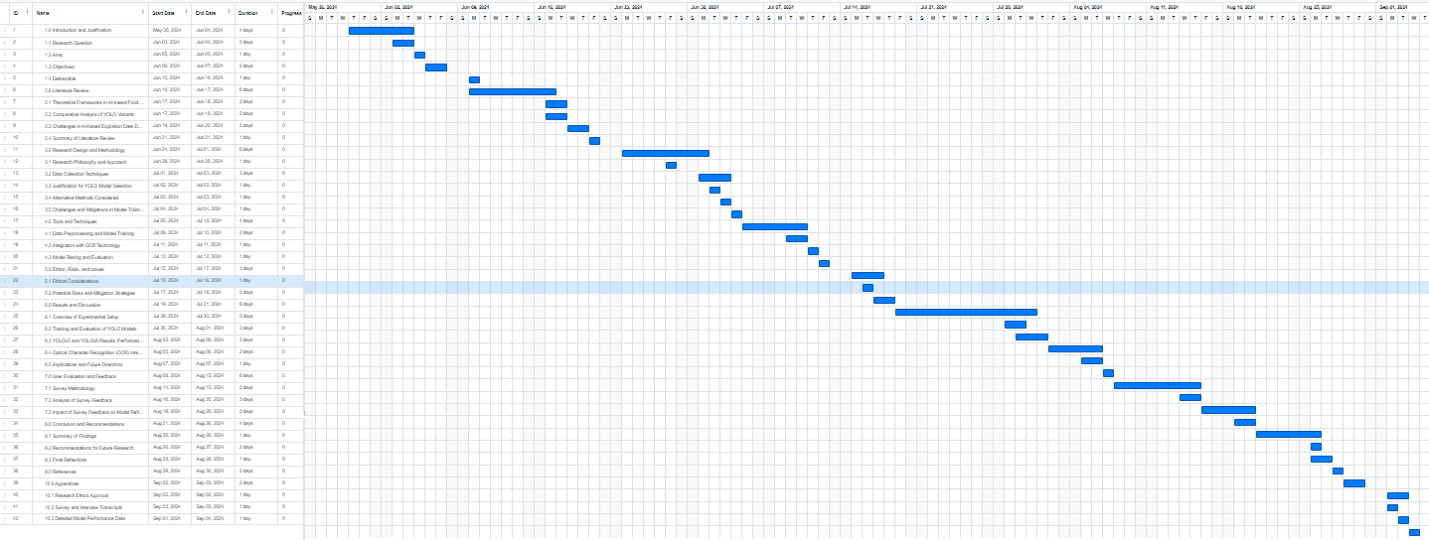

Figure Gantt Chart

### 3.9 Alternative tools considered

Although the initial phase of the project focused solely on object detection using YOLO models, I considered integrating Optical Character Recognition (OCR) technology as an additional tool to enhance the system's capabilities. OCR could have been employed to extract text data from food packaging images in cases where the expiration date might not be easily detectable by object detection models alone. This integration could have involved using OCR libraries such as Tesseract or Google Vision API to recognise textual information more accurately. However, due to time constraints, I was unable to fully implement this feature within the scope of the current project.

## 5.0 Ethics, Risks, and Issues

### 5.1 Ethical Considerations

When developing an AI-driven system for expiry date detection, it is essential to strictly adhere to the ethical standards set out by the University Research Ethics Committee (UREC). This applies especially when handling datasets such as ExpDate, which consist of images of food packaging. Although personal or sensitive data is not involved, transparency in how data is collected, stored, and processed is fundamental. This approach aligns with Sheffield Hallam University's commitment to research integrity, as outlined in the Research Ethics Policy and Procedures, and complies with the UK Data Protection Act 2018, which implements GDPR. By adhering to these legal and ethical requirements, the transparency of data handling is ensured, fostering both ethical integrity and public trust in research.

Even though personal data is not collected, it is crucial that participants are fully informed of their rights, including how their data is processed, stored, and their ability to request its erasure when no longer needed. This guarantees that data is handled lawfully, fairly, and securely, as required by GDPR. The UREC guidelines emphasise that participants must be able to freely withdraw from the study at any point without facing adverse consequences, and their anonymity must be strictly safeguarded.

Additionally, regular evaluation of the AI models is necessary to detect and mitigate potential biases, such as favouring certain expiry date formats or packaging types over others. This is in line with the Guiding Principles of UREC, which stress the importance of fairness, beneficence, and non-malfeasance. Ensuring that the system performs consistently across various packaging types upholds the principles of fairness and accuracy, as required by GDPR and the University's ethical research framework.

Further, transparency in the AI’s decision-making process is paramount. Users and participants must understand how the system processes information and makes decisions. Upholding transparency ensures accountability, a key element in the ethical development of AI systems. This is consistent with the UREC's focus on maintaining integrity and trust in research, which is essential to protecting participants' interests and minimising harm.

The public opinion survey conducted as part of this research was designed in accordance with these ethical commitments. Participants were informed of their rights through a comprehensive consent form, including their right to withdraw at any time. The survey was conducted anonymously, with data protection measures in place to ensure confidentiality. Survey feedback revealed concerns regarding privacy and data security, with 50% of respondents emphasising the need for transparency in data usage policies. This highlights the importance of adhering not only to GDPR standards but also to the ethical guidelines laid out in the University's Research Ethics Policy and Procedures.

Adhering to these ethical guidelines by ensuring transparency, addressing potential biases, and safeguarding data privacy allows the AI system for expiry date detection to comply with both legal and ethical standards while also fostering public trust. Upholding these principles is crucial for promoting the widespread adoption and long-term success of AI-driven solutions aimed at reducing household food waste.

### 5.2 Potential Risks and Mitigation Strategies

The accuracy of AI-based expiration date detection is paramount. Misidentifying expiration dates could lead to incorrect information, potentially resulting in unnecessary food disposal or the consumption of expired products, which can have health implications. Another significant risk is the over-reliance on AI systems, which may diminish users’ attentiveness to expiration dates and reduce their proactive involvement in managing food. Additionally, the system must be accessible to users with varying levels of technological proficiency to avoid excluding those who may struggle with advanced digital tools.

To mitigate these risks, it is crucial to implement rigorous data validation processes and continuously update the AI models to improve accuracy and address any detected biases. Educating users about the system’s capabilities and limitations will empower them to make informed decisions, using the AI as a support tool rather than a sole reliance. Ensuring the system is intuitive and accessible to a broad range of users is also essential, which may involve simplifying the user interface and offering support materials. While this project does not involve direct user interaction, future development could include gathering user feedback to refine the system further, ensuring it remains a responsible and effective tool in reducing household food waste.

## ****6.0 Results and Discussion:**** ****YOLOv5 & YOLOv8****

This section presents a detailed analysis of the results from the YOLOv5 and YOLOv8 experiments, focusing on key performance metrics such as training curves, precision, recall, mAP, and class-specific detection performance. These findings are tied back to user feedback and sustainability goals, while also addressing the core research question: How can YOLO models enhance the accuracy of expiration date classification to reduce food waste? By evaluating these models, this section demonstrates how their accuracy in detecting expiration dates supports the objective of minimising household food waste through timely identification of expiration dates.

### ****6.1 Algorithm Performance: YOLOv5 and YOLOv8****

Both YOLOv5 and YOLOv8 demonstrated strong results in expiration date detection, but YOLOv8 showed clear improvements in handling more visually complex and challenging scenarios. This improvement aligns with the findings from Fang et al. (2023) and Liegeard and Manning (2020), who emphasised the need for AI solutions to mitigate food waste by enhancing detection in real-world environments. YOLOv5 reliably detected expiration dates, due dates, and product codes, but YOLOv8 surpassed these results, particularly in environments with noise and clutter. This enhanced performance supports the objective of developing a system capable of functioning effectively in practical household settings, where lighting and clutter present significant challenges.

User feedback further underscores the practical importance of these findings. The surveys revealed that users often encounter cluttered kitchens or poorly lit refrigerators, which can obscure expiration dates. YOLOv8’s superior performance in these scenarios highlights its real-world applicability, making it a more reliable tool for reducing household food waste, a primary aim of this research.

The analysis of training and validation loss curves for both models reveals how each learned to detect expiration dates. YOLOv5 showed steady progress over 50 epochs, with its bounding box loss and objectness loss stabilising by epoch 40. This indicates effective learning without overfitting, suggesting that the model generalises well to unseen data. However, YOLOv8 exhibited faster convergence, with significant reductions in box, classification, and distribution-focused losses (DFL) by epoch 30. This faster learning curve supports the need for efficient detection in real-world applications, as highlighted by Onyeaka et al. (2023), who stressed the importance of optimising AI models for practical deployment. The efficiency of YOLOv8 directly contributes to more accurate and timely expiration date detection, an essential factor in minimising household food waste.

Evaluating precision, recall, and mAP metrics further illustrates how these models align with the research objectives. YOLOv5 achieved precision values exceeding 0.9 across all classes, while recall values surpassed 0.85, reflecting its capability to effectively detect true positives and minimise false positives. The model’s mAP@0.5 score of 0.95 demonstrates its robustness, especially in detecting expiration dates with only minor localisation variances. However, in more complex scenarios, such as when dealing with small or distorted text, the stricter mAP@0.5:0.95 value of 0.85 revealed some limitations.

YOLOv8 improved upon these results, demonstrating precision scores between 0.85 and 0.95, reducing false positives further while maintaining a high recall of over 0.8. This model's ability to detect smaller and more complex expiration dates in cluttered environments directly addresses the primary research question. As Fang et al. (2023) noted, AI’s ability to improve waste management systems depends on precise data handling, and YOLOv8’s metrics show how AI can enhance expiration date detection, thereby contributing to the reduction of food waste.

Class-specific detection performance further highlights how each model handles the varying conditions presented by real-world packaging. YOLOv5 demonstrated strong performance across a range of fonts, sizes, and orientations, accurately detecting multiple expiration dates within the same image. This reliability aligns with the broader objective of promoting sustainable consumption practices by ensuring that expiration dates are detected accurately, even in cluttered environments, as discussed by Stangherlin and de Barcellos (2018).

YOLOv8’s performance was even more impressive in visually complex scenarios. The model consistently produced high-confidence predictions, reducing misclassification between similar labels such as “due” and “code.” This capability is particularly important in household scenarios where overlapping or closely packed expiration dates are common, ensuring that the model can adapt to the diverse conditions typical of real-world environments.

### ****6.2 Detailed Visual Examples of Expiration Date Detection****

The visual examples from the validation predictions highlight the practical application of both models. YOLOv5’s predictions, illustrated in Figures 2 and 3, show high precision and recall under various lighting and packaging conditions. While there was some minor confusion between the “due” and “code” classes, these errors were infrequent. YOLOv5’s ability to distinguish between expiration dates and other labels in diverse scenarios confirms its practicality for reducing food waste by preventing missed expiration dates.

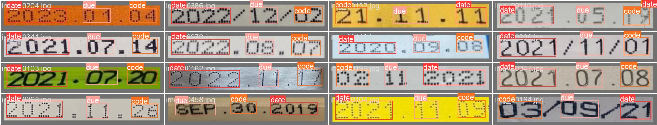

Figure Yolo v5 prediction

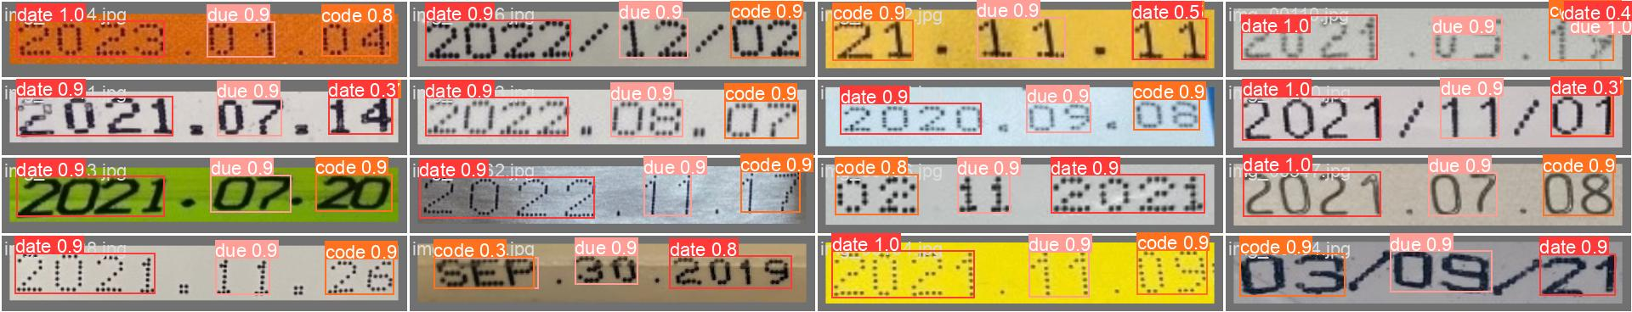

Figure Yolo v5 prediction 2

YOLOv8’s visual results, shown in Figures 4 and 5, further demonstrate its superior performance in handling challenging conditions such as varied text sizes, orientations, and background colours. The model’s consistently high confidence levels strengthen its reliability for household use, addressing the critical need for accurate expiration date detection as part of sustainable food consumption practices, as supported by the literature.

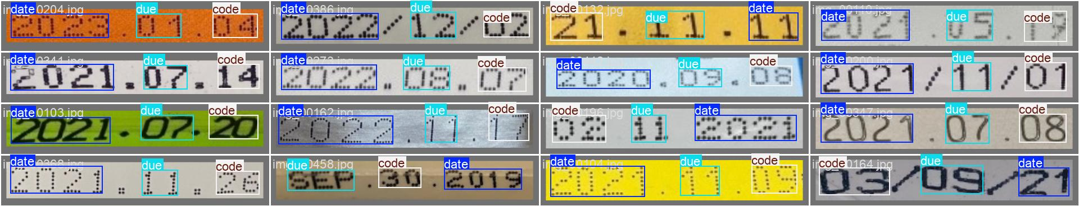

Figure Yolov8 label prediction

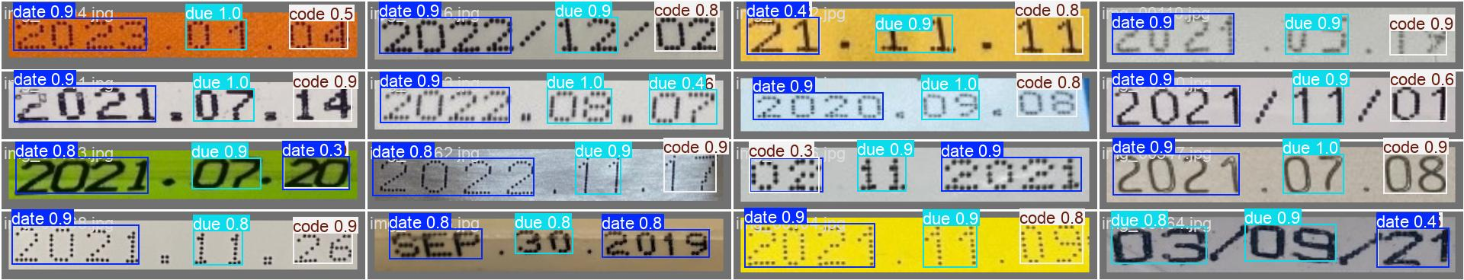

Figure Yolo v8 label prediction 2

### ****6.3 Implications for Food Waste Reduction****

The improved detection accuracy of both YOLOv5 and YOLOv8 has direct implications for reducing household food waste. As the literature review outlined, missing expiration dates often leads to the premature disposal of consumable items, contributing significantly to food waste. By ensuring that fewer expiration dates are missed, both models, especially YOLOv8, play a crucial role in addressing this issue. The enhanced precision and recall of YOLOv8 offer a more robust solution, ensuring that fewer items are unnecessarily discarded, which aligns directly with the research objective of promoting sustainable consumption.

Feedback from household trials further supported this, with many users expressing that missed expiration dates were a key factor in premature food disposal. This reinforces the idea that improving the accuracy of expiration date detection can directly reduce household food waste, as also supported by the studies of Fang et al. (2023) and Onyeaka et al. (2023).

### ****6.4 Limitations and Areas for Improvement****

Despite the models' strengths, limitations remain. YOLOv5 sometimes exhibited confusion between visually similar classes, such as “due” and “code,” particularly in cases of text overlap. Low-light conditions or distorted packaging also posed challenges for the model, leading to occasional misclassifications. Addressing these limitations could involve refining the dataset and implementing more advanced post-processing techniques, as recommended by Seker and Ahn (2022).

Similarly, YOLOv8, while reducing class confusion, still encountered some overlap between similar classes and struggled under extreme conditions, such as heavily distorted text or poor lighting. Continued refinement in these areas, such as through the integration of Optical Character Recognition (OCR) or advanced generative augmentation techniques, could further enhance both models' performance.

### ****6.5 Future Directions****

Looking forward, expanding the dataset to include more diverse and complex conditions will help improve the robustness of both YOLOv5 and YOLOv8. Addressing limitations in low-light scenarios or with heavily distorted text will help ensure the models can adapt to a broader range of real-world conditions, enhancing their practical application in reducing household food waste. As suggested by Liegeard and Manning (2020), leveraging advanced post-processing techniques and exploring new augmentation strategies will be critical in refining these models further.

For YOLOv8, incorporating OCR into the post-processing pipeline could reduce class confusion and improve text recognition accuracy, particularly for low-resolution or distorted images. Further research should also address user concerns related to privacy and data security, especially in household environments, ensuring the system remains both effective and user-friendly.

In addition to technical improvements, future studies should explore the broader societal and environmental impacts of accurate expiration date detection. As highlighted by the UN’s Sustainable Development Goals (SDG 12), reducing food waste plays a key role in promoting responsible consumption and production. Accurate expiration date detection supports this goal, and future research could examine how these models contribute to lowering the environmental footprint associated with food production and waste.

## 

## 7.0 User Evaluation and Feedback

### Survey Section for Dissertation

#### Public Opinion Survey on AI-Driven Solutions for Reducing Household Food Waste

This section outlines the detailed survey questions designed to gather public opinions on the use of AI technology for tracking food expiration dates and reducing household food waste. The questions are structured to assess various aspects such as public awareness, perceived necessity, likelihood of adoption, effectiveness, and privacy concerns associated with AI-driven solutions. The responses will provide valuable insights for developing and implementing AI systems to mitigate household food waste.

#### Purpose of the Survey

The survey aims to:

1. Evaluate public awareness about food waste and technologies that can help reduce it.
2. Assess the perceived necessity and importance of AI-driven systems for tracking food expiration dates.
3. Determine the likelihood of adoption of such technologies by households.
4. Understand the challenges faced by households in managing food expiration dates.
5. Identify any privacy or ethical concerns related to the use of AI in this context.

### 7.1 Survey Methodology

#### 7.1.1 Research Design

The survey was designed to collect both quantitative and qualitative data regarding public opinions on AI-driven solutions aimed at reducing household food waste. The research utilised a structured survey to explore key factors such as public awareness of food waste issues, the perceived necessity of AI systems for tracking expiration dates, and the potential challenges related to their adoption.

#### 7.1.2 Survey Instrument

A questionnaire was developed to gather public opinions on various aspects related to AI-driven systems for reducing food waste. It included a mix of closed and open-ended questions, allowing for both numerical data and in-depth insights. The questions were organised into sections to assess public awareness, perceived importance, challenges in managing food expiration dates, privacy concerns, and the likelihood of adopting AI-driven applications.

#### 7.1.3 Sample and Sampling Method

The survey targeted a broad demographic to ensure diversity in household sizes and food consumption habits. Participants were recruited online through social media platforms such as Facebook, LinkedIn, and Twitter to maximise reach. A convenience sampling method was employed due to the exploratory nature of the study and practical constraints.

#### 7.1.4 Data Collection Procedure

The survey was administered via Google Forms, with anonymity guaranteed to encourage candid responses. Data collection took place over a two-week period, allowing participants ample time to complete the questionnaire at their convenience. Responses were automatically recorded and securely stored in a password-protected database.

#### 7.1.5 Ethical Considerations

The survey adhered to the ethical guidelines established by Sheffield Hallam University’s research ethics committee. Participants were informed of the study’s purpose and their right to withdraw at any time. No personally identifiable information was collected, ensuring complete anonymity throughout. Participants provided informed consent prior to starting the survey.

### 7.2 Analysis of Survey Feedback

The survey results provide important insights into household behaviours, attitudes towards food waste, and the potential for AI-driven solutions to address these challenges. By analysing responses, the survey sheds light on the practical difficulties households face in managing expiration dates and the potential benefits of implementing AI systems like the proposed YOLO models. This analysis informs the project’s broader aim of reducing household food waste through improved expiration date detection.

#### 7.2.1 Household Size, Awareness, and Current Food Management Practices

Household Size, Awareness, and Current Food Management Practices

Household size emerged as a significant factor influencing food management behaviours, with 50% of respondents living in medium-sized households (3-4 members), 30% in smaller households (1-2 members), and 20% in larger households (5 or more members). These dynamics impact how food is consumed and wasted. Larger households, managing greater food volumes, may overlook expiration dates more frequently, while smaller households could struggle to consume food before it spoils. Understanding these nuances helps inform how an AI-driven system like the YOLO model should be designed to cater to varying household needs, emphasising adaptability and flexibility in managing food expiration dates efficiently.

Awareness of food waste was also a critical finding, with only 10% of respondents indicating that they are very aware of how much food their household wastes annually, while 50% are somewhat aware and 20% are not aware at all. This aligns with the literature’s suggestion that most households are not fully conscious of their food waste habits, emphasising the need for solutions that not only track expiration dates but also raise awareness about consumption patterns. The implementation of YOLO models can incorporate features that track and report waste patterns, promoting more sustainable consumption—a key objective of this research.

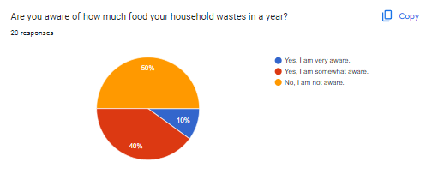

Figure Household waste in a year

Additionally, when asked how households currently manage food expiration dates, 70% of respondents reported relying on manual methods, such as visual checks and memory, while only 30% use digital tools. This significant reliance on manual methods highlights the potential for error and mismanagement, which AI systems could address by offering a more reliable, automated approach. The need for such automation directly supports the research objective of implementing and evaluating YOLO models to minimise food waste through accurate expiration date detection.

#### 7.2.2 Challenges in Expiration Date Management and Food Discarding Behaviour

The survey identified several challenges that households face when managing expiration dates. Forty per cent of respondents reported forgetting to check expiration dates as their primary challenge, 30% found it difficult to read labels, and another 30% mentioned confusion caused by multiple dates on packaging. These issues are consistent with findings in the literature, which highlight expiration date mismanagement as a leading cause of food waste in households. The proposed AI system using YOLO models aims to address these challenges by automating the identification and tracking of expiration dates, reducing the burden on users while improving accuracy.

Regarding food discarding behaviour, 40% of households reported discarding food occasionally due to expiration dates, with 30% discarding food frequently and 30% rarely doing so. This pattern underscores the role expiration dates play in food waste, reinforcing the need for a solution that helps households track dates more effectively to minimise waste. By addressing these challenges, the AI system can contribute to the research goal of reducing food waste through improved food management.

#### 7.2.3 Technological Awareness and Adoption Potential

Technological awareness, particularly of solutions that help reduce food waste, was relatively low among respondents, with 60% unaware of existing technologies such as Kitche, and 40% familiar with them. This lack of awareness points to a significant gap in the market for AI-driven solutions that are both accessible and user-friendly. The proposed YOLO model system could address this gap by offering a straightforward tool that automates food expiration date tracking, making it easier for users to manage their food consumption. This finding supports the objective of encouraging the adoption of AI-based solutions to reduce food waste.

When respondents were asked about the perceived necessity of AI-driven systems for managing food expiration dates, 60% believed that such a system is necessary for reducing food waste, 30% were neutral, and 10% disagreed. This general support for AI-based solutions reflects the positive potential for public acceptance of the system proposed in this dissertation. Moreover, 70% of respondents believed that an automated system for tracking expiration dates would effectively reduce food waste, aligning with the project’s goal of creating a reliable, efficient solution for managing expiration dates.

#### 7.2.4 Concerns, Incentives, and Willingness to Adopt AI-Driven Solutions

Despite the general support for AI-driven systems, privacy and data security emerged as significant concerns for respondents. Fifty per cent of participants expressed concerns about how their data would be used, 30% emphasised the need for transparent data usage policies, and 20% wanted the ability to opt out of data sharing. Addressing these concerns is crucial for ensuring widespread adoption of the proposed AI system. Implementing strong data security measures and offering users control over their data would build trust and increase the likelihood of adoption, directly aligning with the research objective of ensuring public confidence in AI-based food management systems.

In terms of adoption potential, 60% of respondents indicated they would likely adopt an AI-driven app for tracking expiration dates, while 20% were unsure and 20% were unlikely to adopt the technology. These findings highlight the need to address privacy concerns and demonstrate the tangible benefits of the system to users. Convenience and financial savings were identified as the top incentives for using such an app, with 50% citing convenience and 30% highlighting financial savings as primary motivators. This suggests that the system should emphasise its ability to simplify food management and reduce costs for users, as these factors will drive adoption.

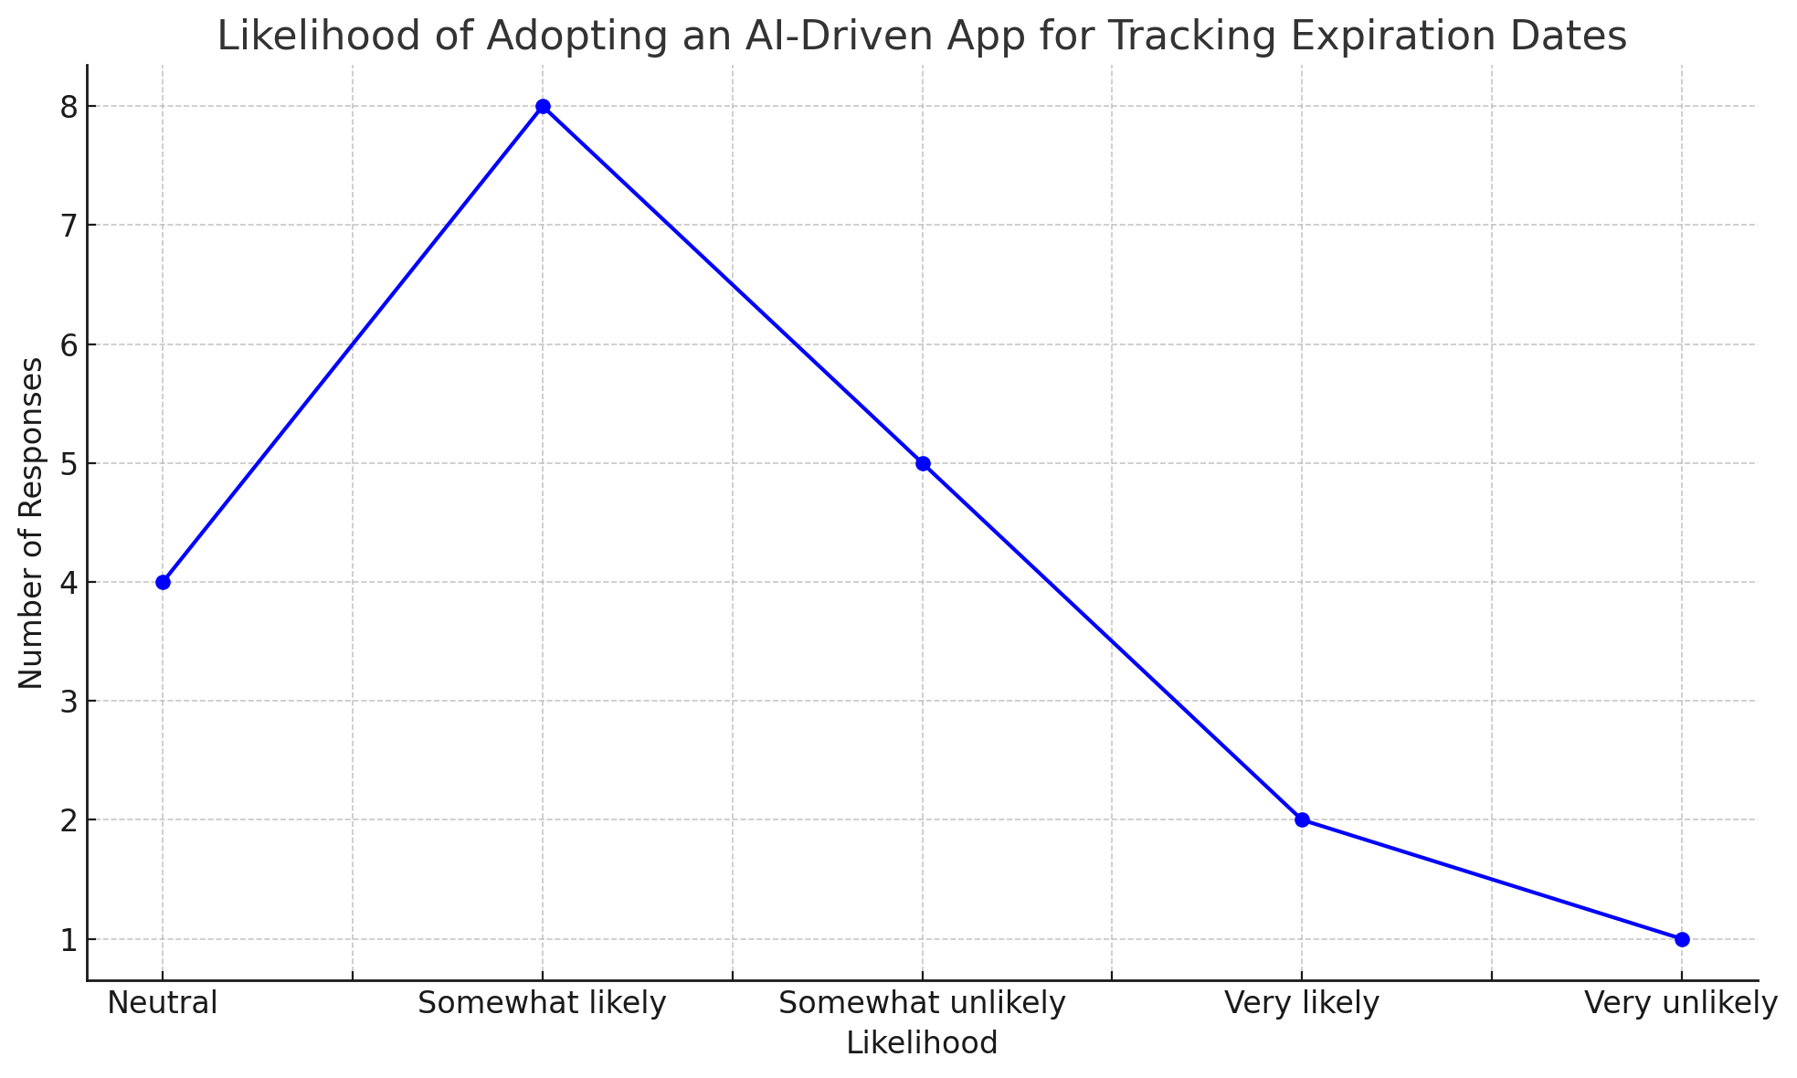

Figure Likelihood of adopting AI App

Furthermore, 60% of respondents preferred a free app, with 20% willing to pay a one-time fee and another 20% open to a subscription model. These preferences suggest that a freemium model, where basic features are free and additional features are available for a fee, could be a viable option for the AI system. By offering basic functionality for free and charging for premium services, the system could meet the diverse needs of its users while ensuring sustainability.

#### 7.2.5 survey conclusion

The survey feedback provides valuable insights into how households perceive and manage food waste and highlights the potential for AI-driven systems to address these challenges. By focusing on key factors such as household size, food waste awareness, current management practices, and privacy concerns, the findings support the dissertation’s aims and objectives. The data suggests that there is a clear demand for more reliable, automated solutions like the proposed YOLO-based system, particularly if it addresses the challenges of expiration date management and provides tangible benefits such as convenience and cost savings. Privacy and data security concerns will need to be addressed to ensure widespread adoption, but the overall feedback points to a strong potential market for AI-driven food management systems that can contribute to reducing household food waste and promoting sustainable consumption.

## 8.0 Conclusion and Recommendations

This dissertation, titled **"Mitigating Household Food Waste Using AI for Sustainable Consumption,"** set out to investigate how AI, specifically YOLO models, can be used to mitigate household food waste by automating the detection of expiration dates. Food waste poses serious environmental and economic challenges, and current methods for tracking expiration dates are inefficient and prone to error. By employing YOLOv5 and YOLOv8 models, the study aimed to automate the process, thereby promoting more sustainable consumption practices. A public opinion survey was also conducted to gauge potential user acceptance of such technology.

The findings of this study demonstrated that both YOLOv5 and YOLOv8 models are effective at detecting expiration dates, with YOLOv8 showing superior accuracy, particularly in challenging conditions such as low-light environments and small or distorted text. This makes YOLOv8 a more suitable candidate for real-world applications aimed at reducing food waste. However, the study also identified several limitations, particularly the lack of dataset diversity and the absence of integrated Optical Character Recognition (OCR) technology, which would allow the models to interpret various expiration date formats more effectively.

The public opinion survey highlighted that while there is a high level of awareness regarding household food waste, there is limited familiarity with AI-based solutions aimed at addressing this issue. Survey respondents acknowledged the difficulties of manually tracking expiration dates and expressed interest in adopting AI-driven systems. However, concerns about privacy and data security were also prominent, indicating that any practical AI solution must prioritise transparency and robust data protection mechanisms.

### 8.1 Summary of Findings

The research has shown that AI-driven systems, particularly those utilising YOLO models, hold significant potential for reducing household food waste by automating expiration date detection. YOLOv8 outperformed YOLOv5 in key areas, including precision and recall, making it more suitable for practical applications. However, challenges remain, particularly in the models' ability to generalise across diverse packaging designs and expiration date formats, and in their lack of OCR integration.

### 8.2 Recommendations for Future Research

Future research should focus on expanding the dataset to include a broader range of packaging designs, expiration date formats, and environmental conditions to enhance the generalisability of the AI models. Integrating OCR technology will also be essential for improving the accuracy of expiration date detection. Additionally, developing lightweight versions of YOLO models for deployment on mobile devices and home assistants could make AI-driven food waste reduction technology more accessible to households.

Addressing privacy and security concerns will be crucial for gaining public trust and ensuring widespread adoption. AI systems must provide transparent data usage policies and offer users control over their data. Future studies should also investigate the broader economic and environmental impacts of AI-driven solutions in reducing food waste, with pilot studies potentially offering valuable insights.

### 8.3 Final Reflections

This dissertation demonstrates the potential for AI, particularly YOLO models, to significantly reduce household food waste by automating expiration date detection. However, further refinements are necessary, particularly in dataset diversity, OCR integration, and addressing privacy concerns. Collaboration between AI researchers, policymakers, and consumers will be essential for the successful deployment of such systems. This research lays the groundwork for future developments in AI-driven household waste reduction technologies and highlights the importance of aligning technological advancements with real-world needs and expectations. As AI continues to evolve, its potential to promote sustainable living and address pressing environmental challenges will only grow.

## 

## 9.0 References

### Introduction

Slorach, P. C., Jeswani, H. K., Cuéllar-Franca, R., & Azapagic, A. (2019). Assessing the economic and environmental sustainability of household food waste management in the UK: Current situation and future scenarios. *Science of the Total Environment*, *710*, 135580. <https://doi.org/10.1016/j.scitotenv.2019.135580>

## Literature review

### Motivations for Addressing Household Food Waste & Exploring Key Drivers

Nunkoo, R., Bhadain, M., & Baboo, S. (2021). Household Food waste: attitudes, Barriers and Motivations. *British Food Journal*, *123*(6). <https://doi.org/10.1108/bfj-03-2020-0195>

*Resources, Conservation and Recycling | Journal | ScienceDirect.com by Elsevier*. (n.d.). Www.sciencedirect.com. <https://www.sciencedirect.com/journal/resources-conservation-and-recycling>

Stangherlin, I. do C., & de Barcellos, M. D. (2018). Drivers and barriers to food waste reduction. *British Food Journal*, *120*(10), 2364–2387. <https://doi.org/10.1108/bfj-12-2017-0726>

*Appetite | Journal | ScienceDirect.com*. (2020). Sciencedirect.com. <https://www.sciencedirect.com/journal/appetite>

Boulet, M., Hoek, A. C., & Raven, R. (2021). Towards a multi-level framework of household food waste and consumer behaviour: Untangling spaghetti soup. *Appetite*, *156*, 104856. <https://doi.org/10.1016/j.appet.2020.104856>

Principato, L., Mattia, G., Di Leo, A., & Pratesi, C. A. (2020). The Household Wasteful Behaviour framework: a Systematic Review of Consumer Food Waste. *Industrial Marketing Management*, *93*. <https://doi.org/10.1016/j.indmarman.2020.07.010>

### Bridging Behavioural Change and Technology in Household Food Waste Management

Principato, L., Mattia, G., Di Leo, A., & Pratesi, C. A. (2020). The Household Wasteful Behaviour framework: a Systematic Review of Consumer Food Waste. *Industrial Marketing Management*, *93*. <https://doi.org/10.1016/j.indmarman.2020.07.010>

*Food Waste App | Kitchen App | Kitche App | Food Waste, Kitche*. (n.d.). Kitche. <https://kitche.co/>

Too Good To Go. (2023). *Save Food - Help The Planet*. Www.toogoodtogo.com. <https://www.toogoodtogo.com/>

### Theoretical Frameworks in AI-based Food Management

Onyeaka, H., Tamasiga, P., Nwauzoma, U. M., Miri, T., Juliet, U. C., Nwaiwu, O., & Akinsemolu, A. A. (2023). Using Artificial Intelligence to Tackle Food Waste and Enhance the Circular Economy: Maximising Resource Efficiency and Minimising Environmental Impact: A Review. *Sustainability*, *15*(13), 10482.

‌ <https://doi.org/10.3390/su151310482>

Ren, Y., Li, Y., & Gao, X. (2024). An MRS-YOLO Model for High-Precision Waste Detection and Classification. *Sensors*, *24*(13), 4339–4339. <https://doi.org/10.3390/s24134339>

Fang, B., Yu, J., Chen, Z., Osman, A. I., Farghali, M., Ihara, I., Hamza, E. H., Rooney, D. W., & Yap, P.-S. (2023). Artificial intelligence for waste management in smart cities: a review. *Environmental Chemistry Letters*, *21*(21). <https://doi.org/10.1007/s10311-023-01604-3>

Liegeard, J., & Manning, L. (2019). Use of intelligent applications to reduce household food waste. *Critical Reviews in Food Science and Nutrition*, 1–14. <https://doi.org/10.1080/10408398.2018.1556580>

### Comparative Analysis of YOLO Variants

A generalized framework for recognition of expiration dates on product packages using fully convolutional networks. (2022). *Expert Systems with Applications*, *203*, 117310. <https://doi.org/10.1016/j.eswa.2022.117310>

Zhang, Y., Deng, L., Zhu, H., Wang, W., Ren, Z., Zhou, Q., Lu, S., Sun, S., Zhu, Z., Gorriz, J. M., & Wang, S. (2023). Deep learning in food category recognition. *Information Fusion*, *98*, 101859. <https://doi.org/10.1016/j.inffus.2023.101859>

### Challenges in AI-based Expiration Date Detection

‌

A generalized framework for recognition of expiration dates on product packages using fully convolutional networks. (2022). *Expert Systems with Applications*, *203*, 117310. Seker & Ahn

<https://doi.org/10.1016/j.eswa.2022.117310>

Zhang, Y., Deng, L., Zhu, H., Wang, W., Ren, Z., Zhou, Q., Lu, S., Sun, S., Zhu, Z., Gorriz, J. M., & Wang, S. (2023). Deep learning in food category recognition. *Information Fusion*, *98*, 101859. <https://doi.org/10.1016/j.inffus.2023.101859>

## Research Design, Methodology, and Tools

### Research Philosophy and Approach

Ramanadhan, S., Revette, A. C., Lee, R. M., & Aveling, E. L. (2021). Pragmatic approaches to analyzing qualitative data for implementation science: an introduction. *Implementation Science Communications*, *2*(1). <https://implementationsciencecomms.biomedcentral.com/articles/10.1186/s43058-021-00174-1>

### Data Collection Techniques

*ExpDate: Expiration Date Dataset*. (n.d.). Acseker.github.io. <https://felizang.github.io/expdate/>

### Justification for YOLO Model Selection and Training Techniques

Terven, J., Córdova-Esparza, D.-M., & Romero-González, J.-A. (2023). A Comprehensive Review of YOLO Architectures in Computer Vision: From YOLOv1 to YOLOv8 and YOLO-NAS. *Machine Learning and Knowledge Extraction*, *5*(4), 1680–1716. <https://doi.org/10.3390/make5040083>

Jiang, P., Ergu, D., Liu, F., Cai, Y., & Ma, B. (2022). A Review of Yolo Algorithm Developments. *Procedia Computer Science*, *199*, 1066–1073. <https://doi.org/10.1016/j.procs.2022.01.135>

### Computational Resources

Google. (n.d.). *Colaboratory – Google*. Research.google.com; Google. <https://research.google.com/colaboratory/faq.html>

*Google Colab*. (2019). Google.com. <https://colab.research.google.com/github/d2l-ai/d2l-tvm-colab/blob/master/chapter_gpu_schedules/arch.ipynb#scrollTo=vSx3BMnOm9L4>

## Ethics, Risks, and Issues

GOV.UK. (2018). *Data Protection*. Gov.UK; www.gov.uk. <https://www.gov.uk/data-protection#:~:text=The%20Data%20Protection%20Act%202018%20is%20the%20UK>

Sheffield Hallam University. (2020, December). *Policies | Sheffield Hallam University*. Www.shu.ac.uk. <https://www.shu.ac.uk/research/excellence/ethics-and-integrity/policies>

<https://www.shu.ac.uk/-/media/home/research/ethics-integrity-and-practice/research-ethics-policy-and-procedures-v10.pdf>

## ****Results and Discussion: YOLOv5 & YOLOv8****

### ****Algorithm Performance: YOLOv5 and YOLOv8****

Fang, B., Yu, J., Chen, Z., Osman, A. I., Farghali, M., Ihara, I., Hamza, E. H., Rooney, D. W., & Yap, P.-S. (2023). Artificial intelligence for waste management in smart cities: a review. *Environmental Chemistry Letters*, *21*(21). <https://doi.org/10.1007/s10311-023-01604-3>

Liegeard, J., & Manning, L. (2019). Use of intelligent applications to reduce household food waste. *Critical Reviews in Food Science and Nutrition*, 1–14. <https://doi.org/10.1080/10408398.2018.1556580>

Onyeaka, H., Tamasiga, P., Nwauzoma, U. M., Miri, T., Juliet, U. C., Nwaiwu, O., & Akinsemolu, A. A. (2023). Using Artificial Intelligence to Tackle Food Waste and Enhance the Circular Economy: Maximising Resource Efficiency and Minimising Environmental Impact: A Review. *Sustainability*, *15*(13), 10482.

‌ <https://doi.org/10.3390/su151310482>

Stangherlin, I. do C., & de Barcellos, M. D. (2018). Drivers and barriers to food waste reduction. *British Food Journal*, *120*(10), 2364–2387. <https://doi.org/10.1108/bfj-12-2017-0726>

A generalized framework for recognition of expiration dates on product packages using fully convolutional networks. (2022). *Expert Systems with Applications*, *203*, 117310. Seker & Ahn

<https://doi.org/10.1016/j.eswa.2022.117310>

### Future directions

United Nations. (2015). *The 2030 Agenda for Sustainable Development’s 17 Sustainable Development Goals (SDGs)*. <https://sdgs.un.org/sites/default/files/2020-09/SDG%20Resource%20Document_Targets%20Overview.pdf>

## 7.0 User Evaluation and Feedback

## ‌8.0 Conclusion and Recommendations

## 10.0 ****Appendix****

### ****Appendix A: Research Project Plan****

#### ****1. Introduction and Justification****

Household food waste is a major environmental and economic issue, contributing to resource inefficiency. In the UK, millions of tonnes of food are wasted annually, with expiry date mismanagement being a significant factor. This research aims to mitigate household food waste by developing an AI-driven solution using YOLO (You Only Look Once) models to detect expiry dates on food packaging. The solution will help households better manage food items and reduce waste.

#### ****2. Research Question****

How can YOLO models enhance the accuracy of expiry date detection to reduce household food waste?

#### ****3. Aims****

The main aim of this project is to develop a functional AI system that accurately detects expiry dates on food packaging, thereby reducing household food waste and improving food management practices.

#### ****4. Objectives****

* **Expiration Date Detection:** Implement and evaluate YOLOv5 and YOLOv8 models to detect expiry dates on food packaging images.  
  **Model Performance Evaluation:** Assess the models' accuracy using metrics such as precision, recall, and mean Average Precision (mAP).
* **Public Perception Survey:** Gather user feedback through surveys to understand the effectiveness and acceptability of AI in managing food waste.
* **Sustainable Consumption Promotion** Examine the broader impact of expiry date detection in fostering sustainable consumption habits.
* **Future Recommendations:** Identify limitations and propose improvements, including the integration of Optical Character Recognition (OCR) for enhanced functionality.

#### ****5. Deliverables****

* A prototype AI system using YOLOv5 and YOLOv8 to detect expiration dates on food packaging.
* A comprehensive report detailing system performance metrics.
* An analysis of user feedback on AI adoption for household food waste management.
* Recommendations for future research, including OCR integration and dataset expansion.

#### ****6. Literature Review Summary****

Key studies indicate that efficient expiration date management is essential for reducing household food waste. Previous research on YOLO models has demonstrated their effectiveness in detecting small objects like expiration dates. However, challenges such as dataset limitations and the need for OCR integration remain, suggesting future advancements are necessary for real-world applications.

#### ****7. Research Methodology****

* **Research Philosophy:** Pragmatism, focusing on the practical application of AI in real-world settings.
* **Data Collection:** Utilise the ExpDate dataset, containing food packaging images with expiration dates. The dataset reflects real-world household conditions.
* **Data Preprocessing:** Implement steps such as normalisation, image resizing, and data augmentation to improve model generalisation.
* **Model Training:** Fine-tune YOLOv5 and YOLOv8 models using transfer learning, assessing performance through precision, recall, mAP, and confusion matrices.
* **Survey:** Distribute an online public opinion survey to gather insights on AI adoption for food waste reduction.

#### ****8. Timeline****



#### ****9. Ethical Considerations****

This research will comply with Sheffield Hallam University’s ethical guidelines. No sensitive or personal data will be collected. Survey participants will remain anonymous, and consent forms will ensure transparency regarding participant rights. The AI models will adhere to ethical standards, ensuring fairness and privacy in data usage.

#### ****10. Risks and Mitigation Strategies****

* **Risk 1:** Misclassification of expiration dates by AI models.
  + **Mitigation:** Regular testing with multiple metrics (precision, recall) to identify and correct errors early in the model training process.
* **Risk 2:** Low survey participation.
  + **Mitigation:** Broaden the survey distribution through social media and online platforms to capture a larger, diverse sample of participants.

#### ****11. Conclusion****

This project will develop and assess AI models (YOLOv5 and YOLOv8) to detect expiration dates on food packaging, helping to reduce household food waste. The integration of technical solutions and public feedback ensures that the research addresses both the technical and social aspects of sustainable food consumption. Future recommendations, including OCR integration, will guide further research and system improvements.

### ****Appendix B: Research Ethics Approval****

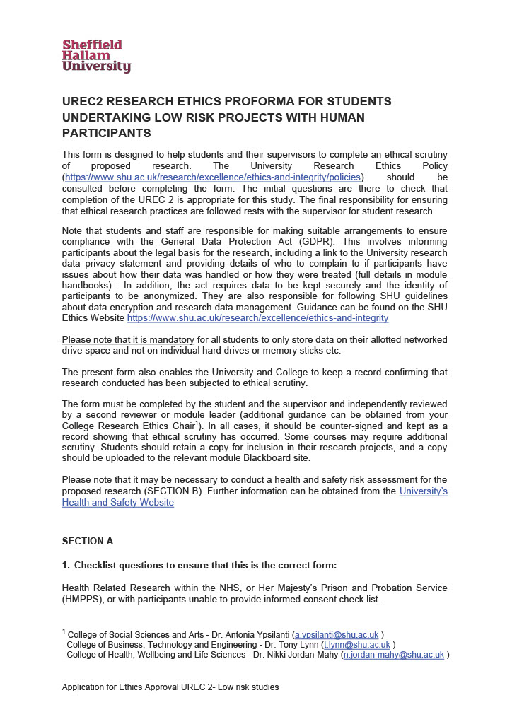

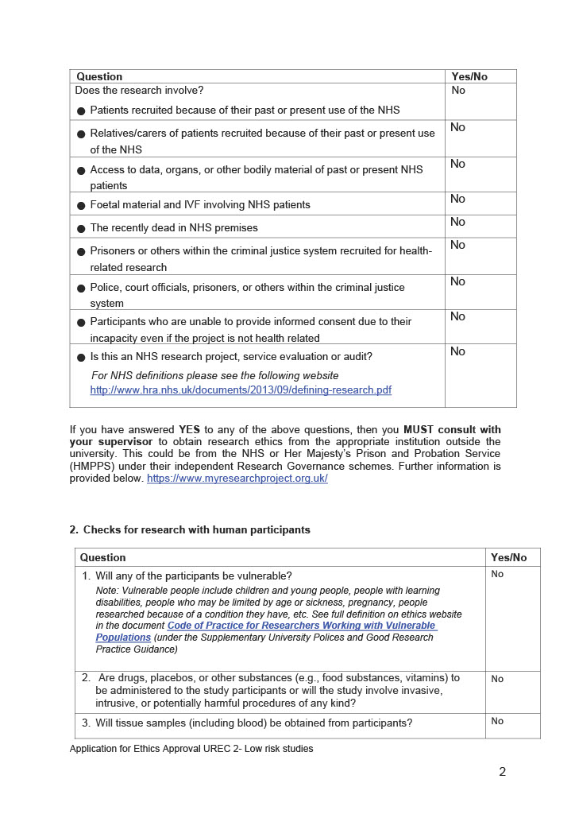

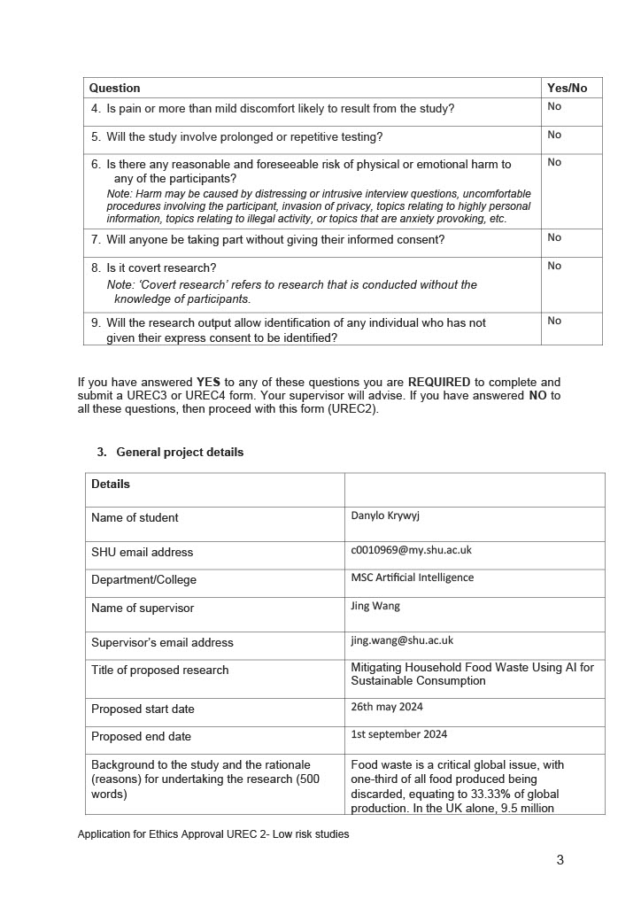

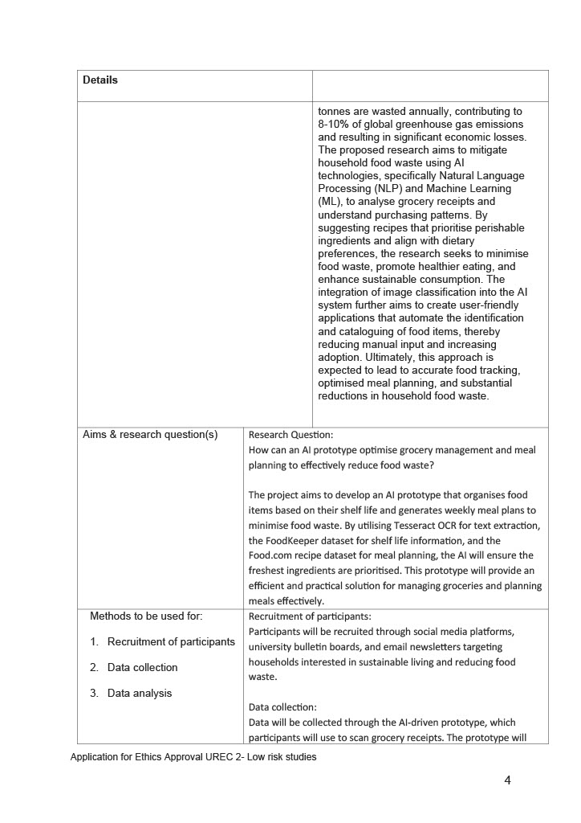

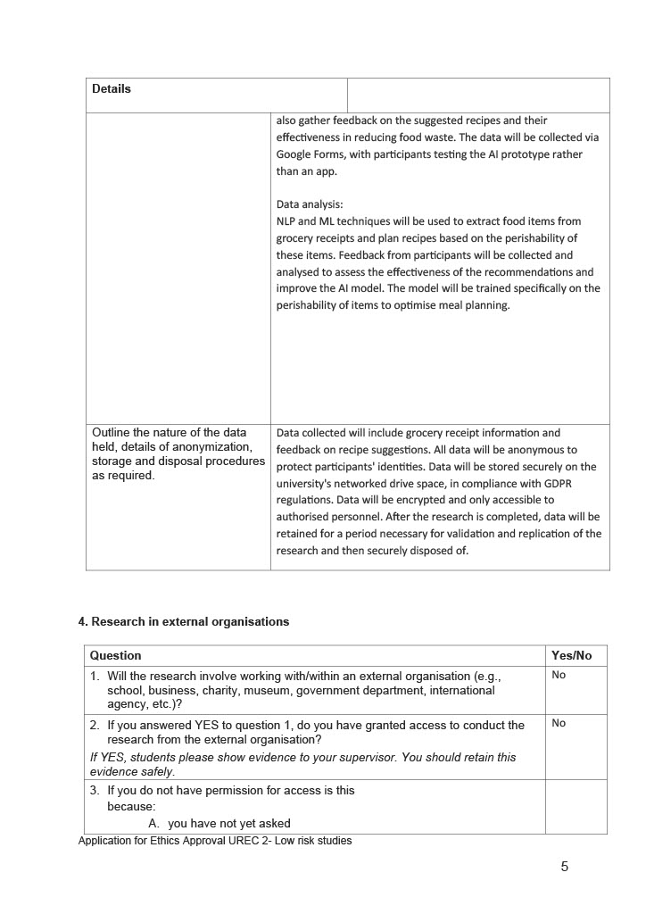

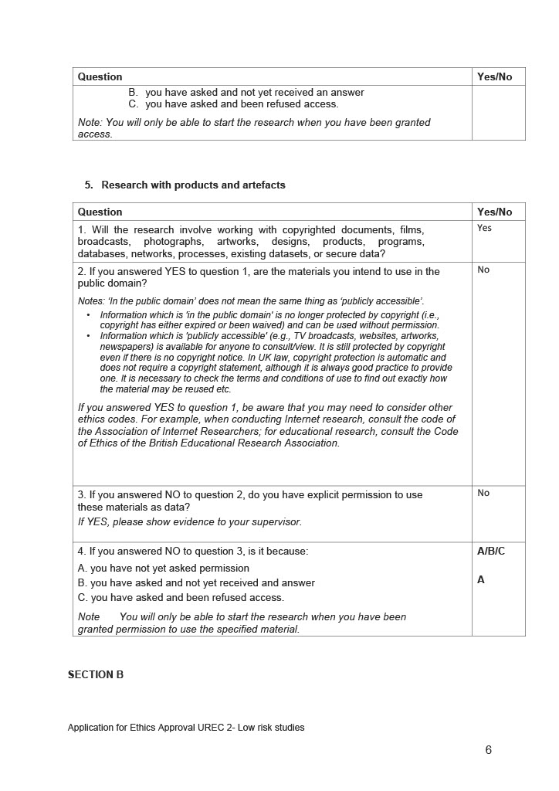

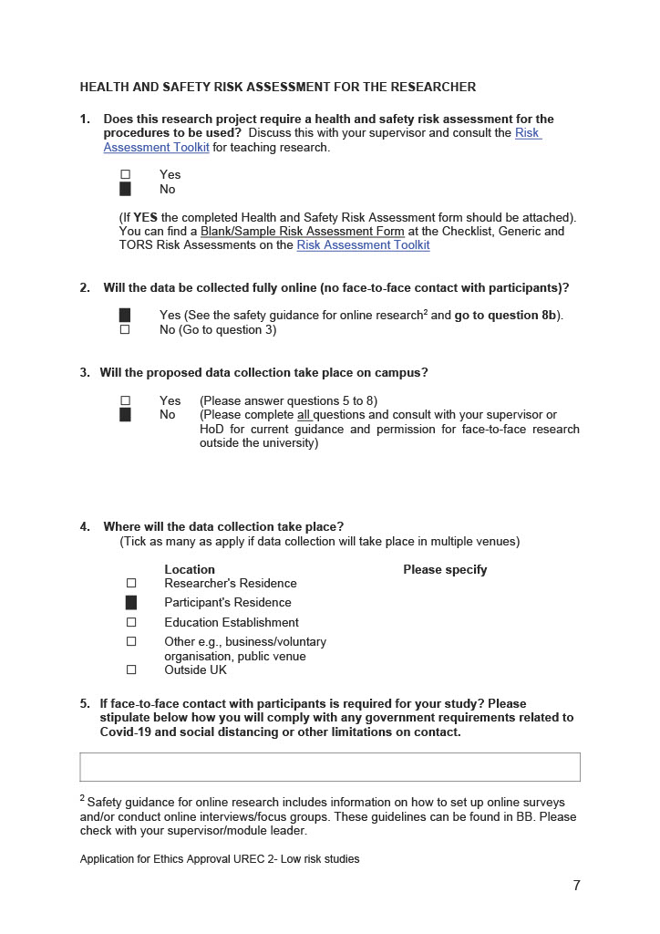

### ****Appendix C: Participant Consent Form****

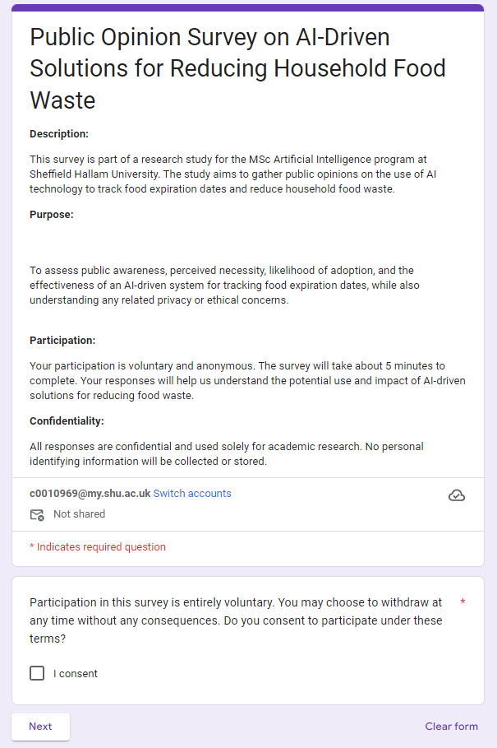

### ****Appendix D: Survey Questionnaire****

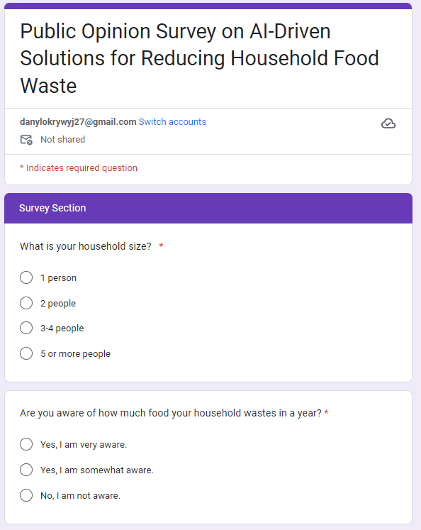

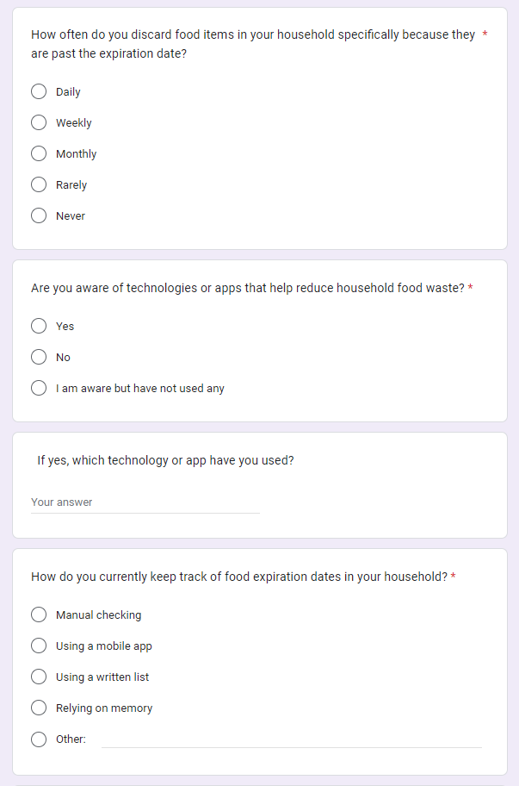

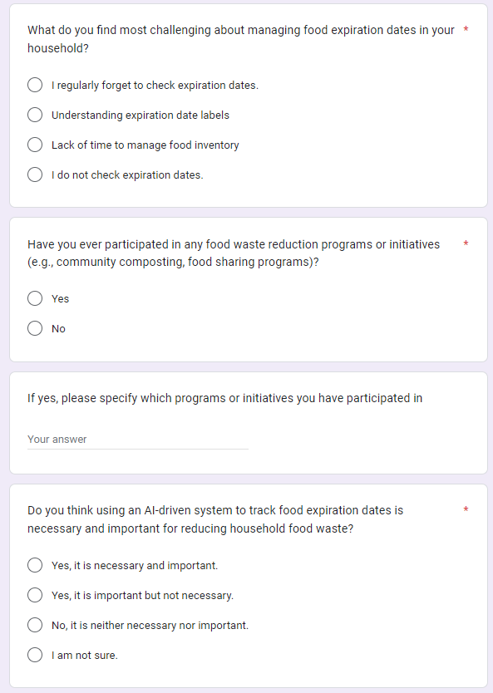

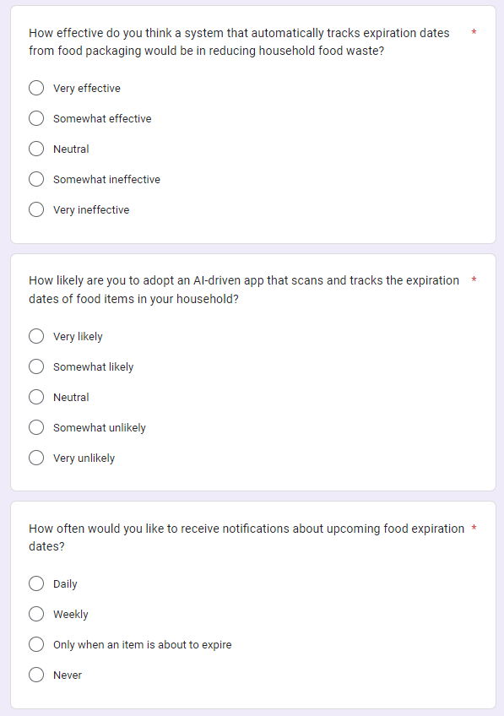

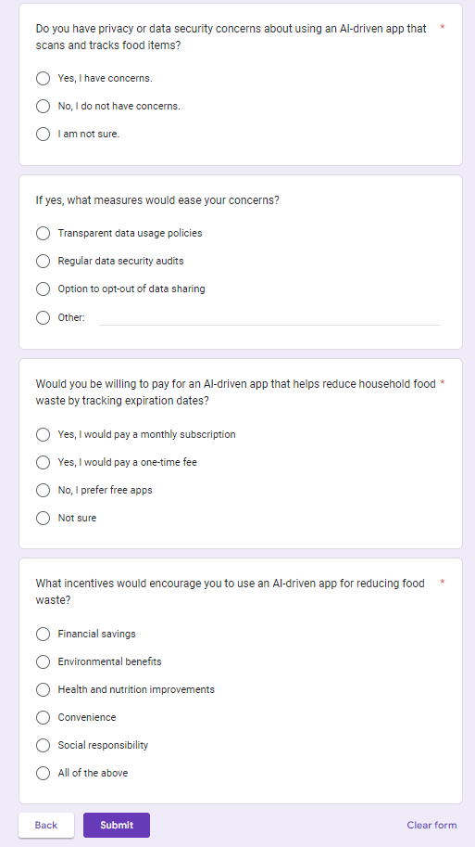

### ****Appendix E: Survey Feedback and Public Survey Results****

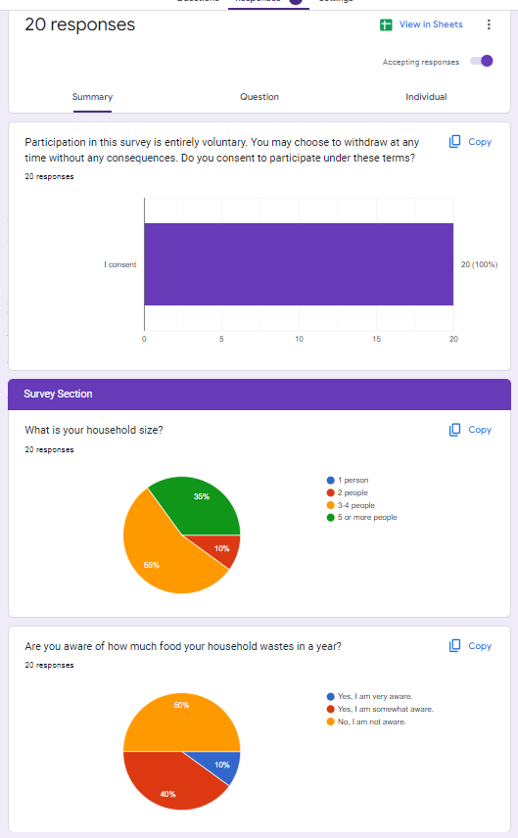.

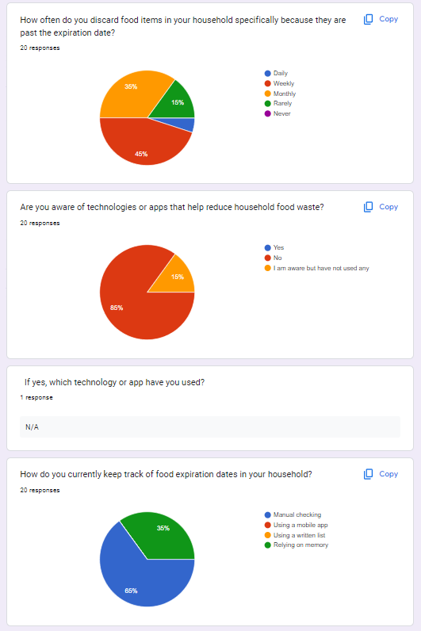

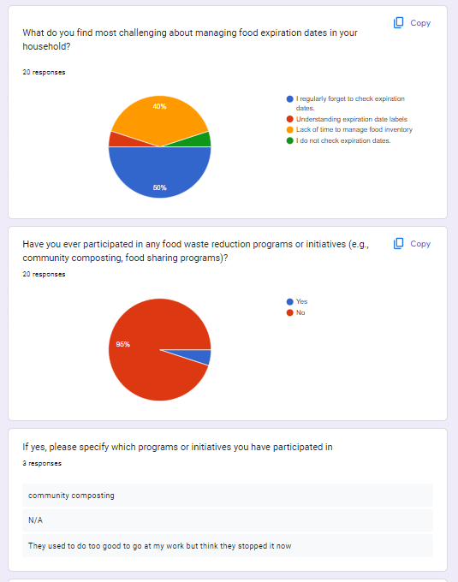

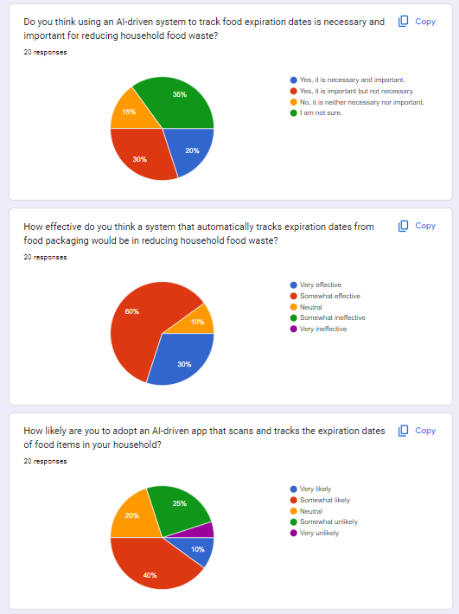

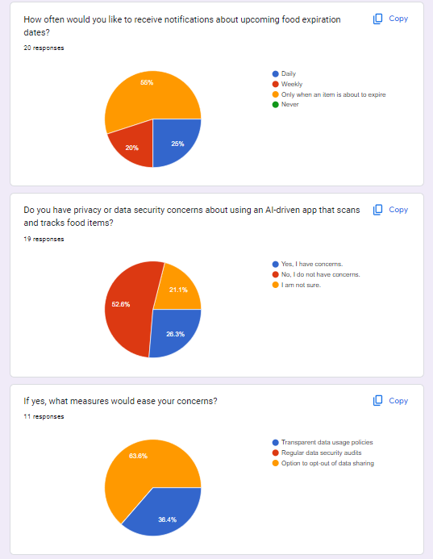

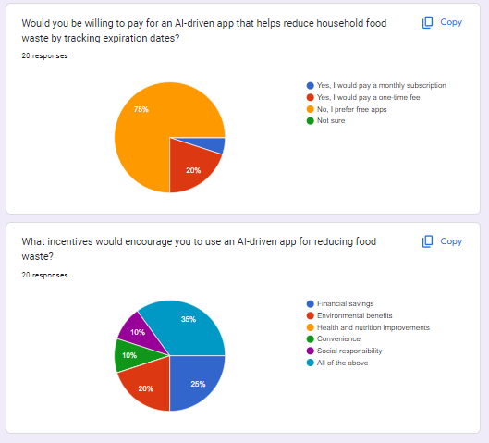

### ****Appendix F: Annotated Code Snippets****

**Google Drive JSON Path Updater and Annotation Processor**

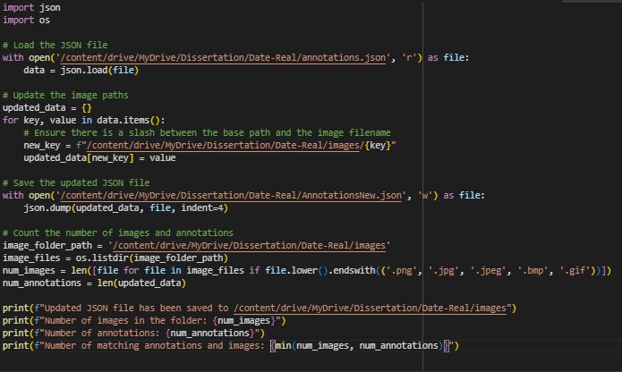

**YOLOv5 Setup and Dependency Installation in Google Drive**

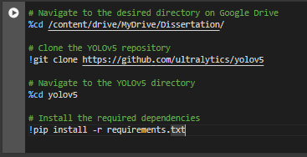

**YOLO V5 Dataset Preparation: Split Images and Labels for Training/Validation**

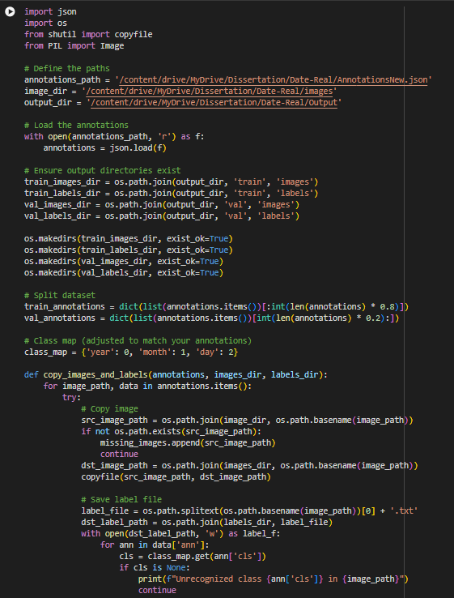

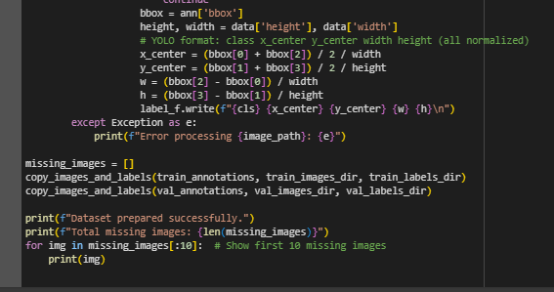

**YOLO V5 Training**

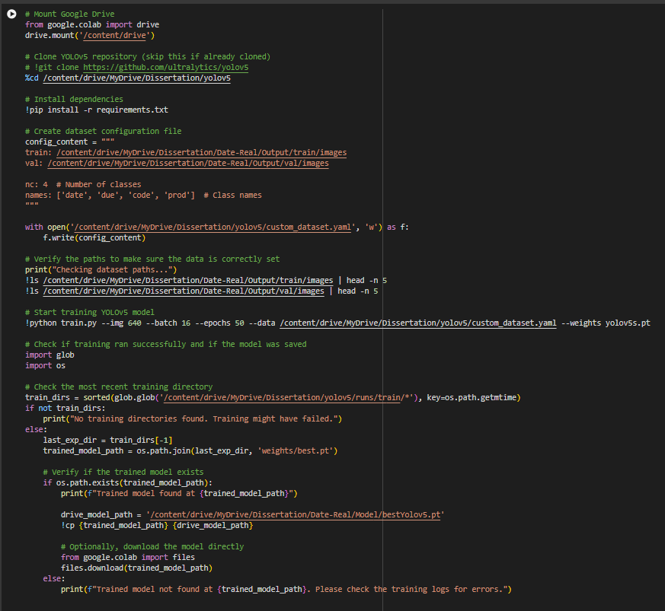

**YOLO V8 Dataset Preparation: Split Images and Labels for Training/Validation**

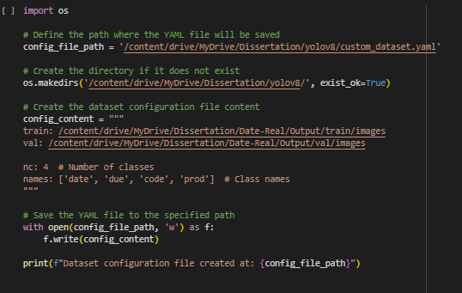

**YOLO V8 Training**

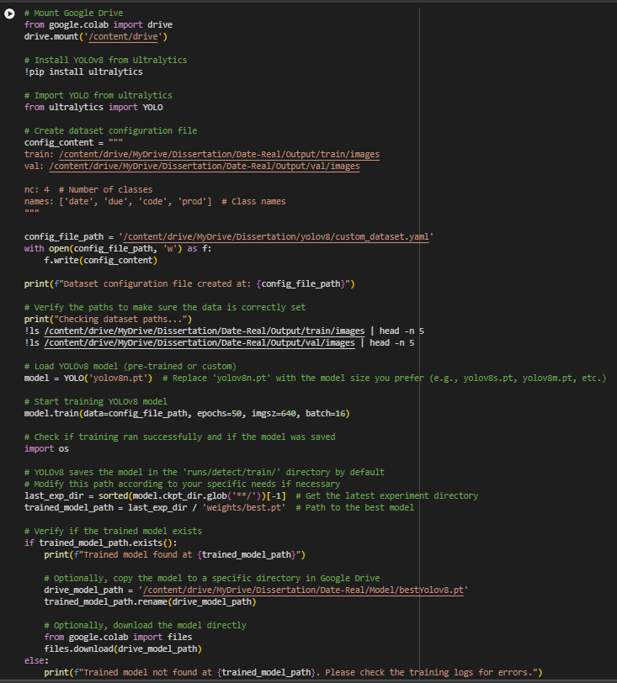

**YOLOv8 Object Detection with OCR Comparison Attempt: Tesseract, EasyOCR, and PaddleOCR**

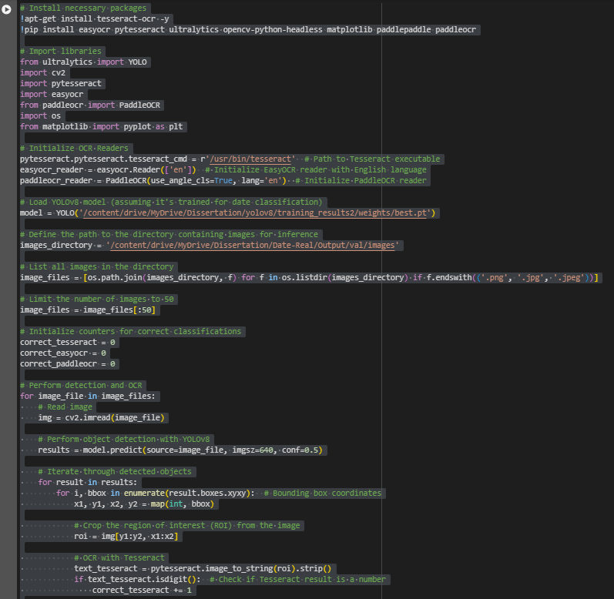

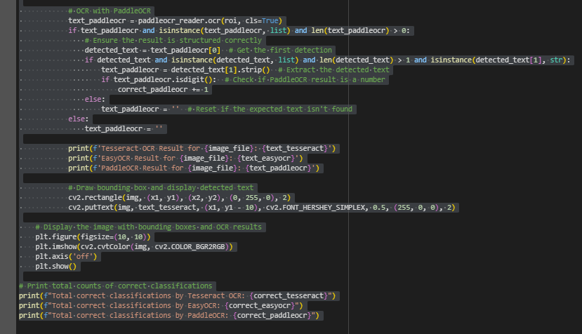

### ****Appendix G: Detailed**** YOLO V5 ****Model Performance Data****

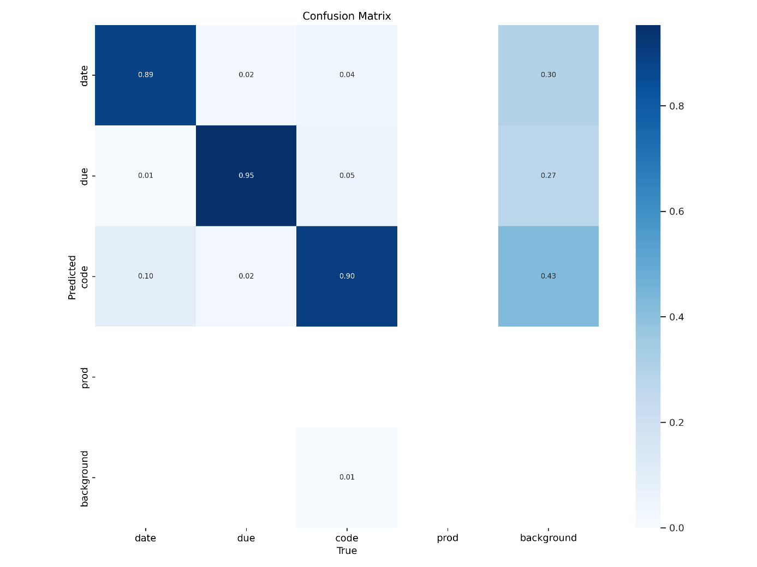

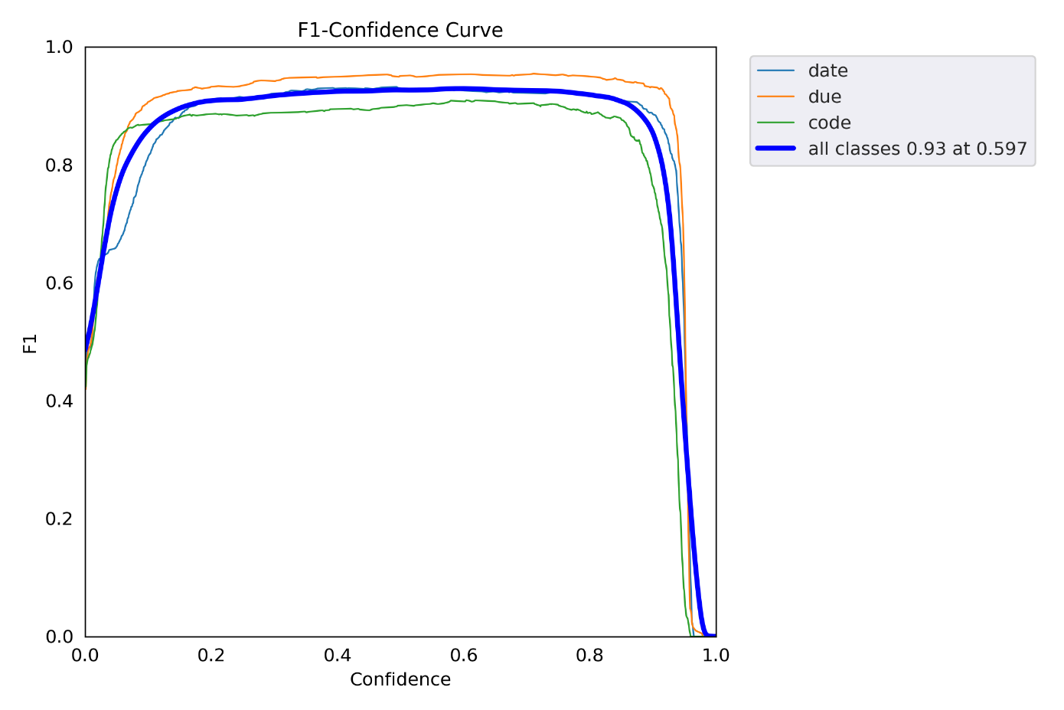

**Labels**

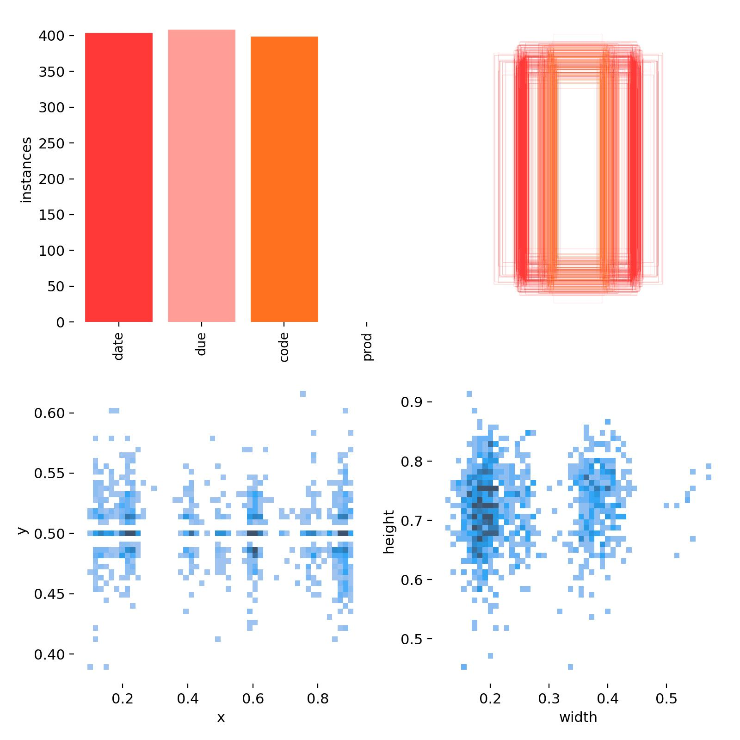

**Labels Correlogram**

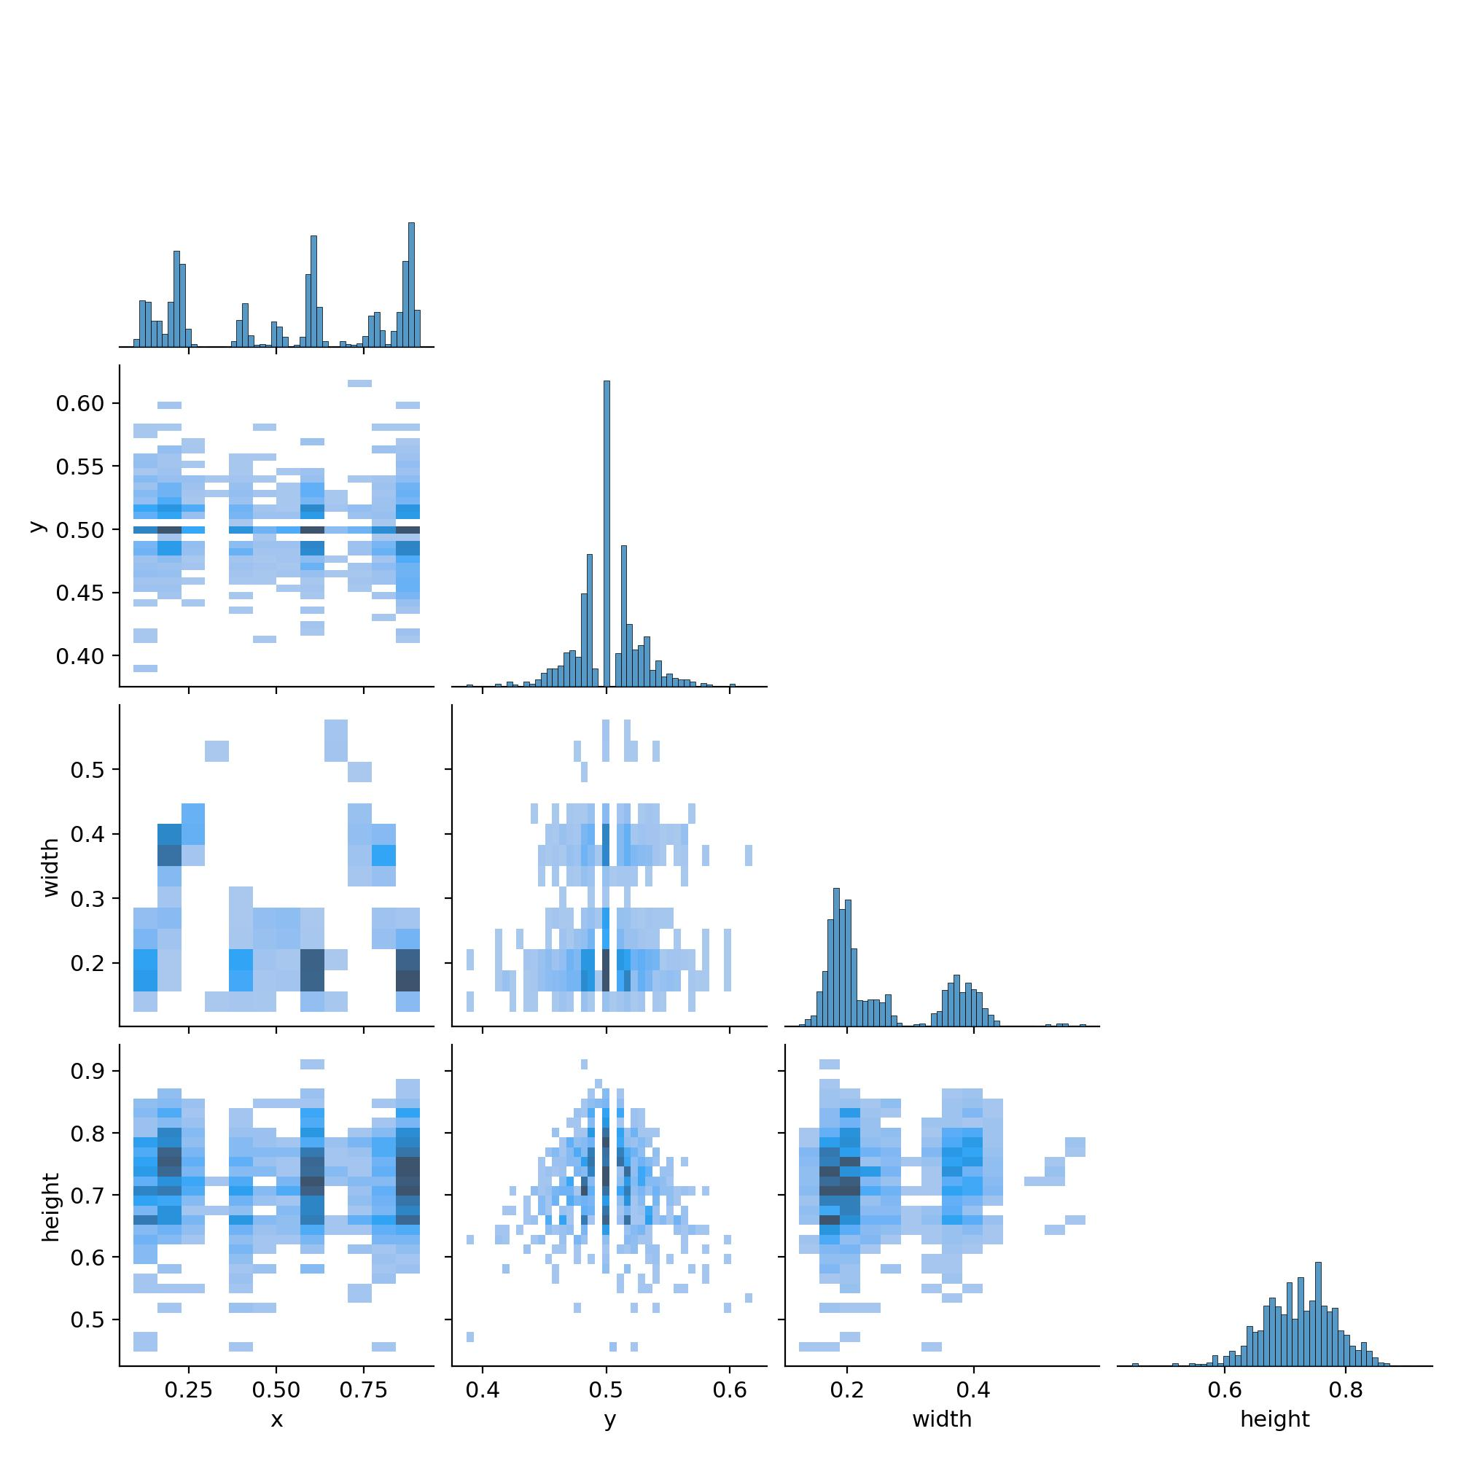

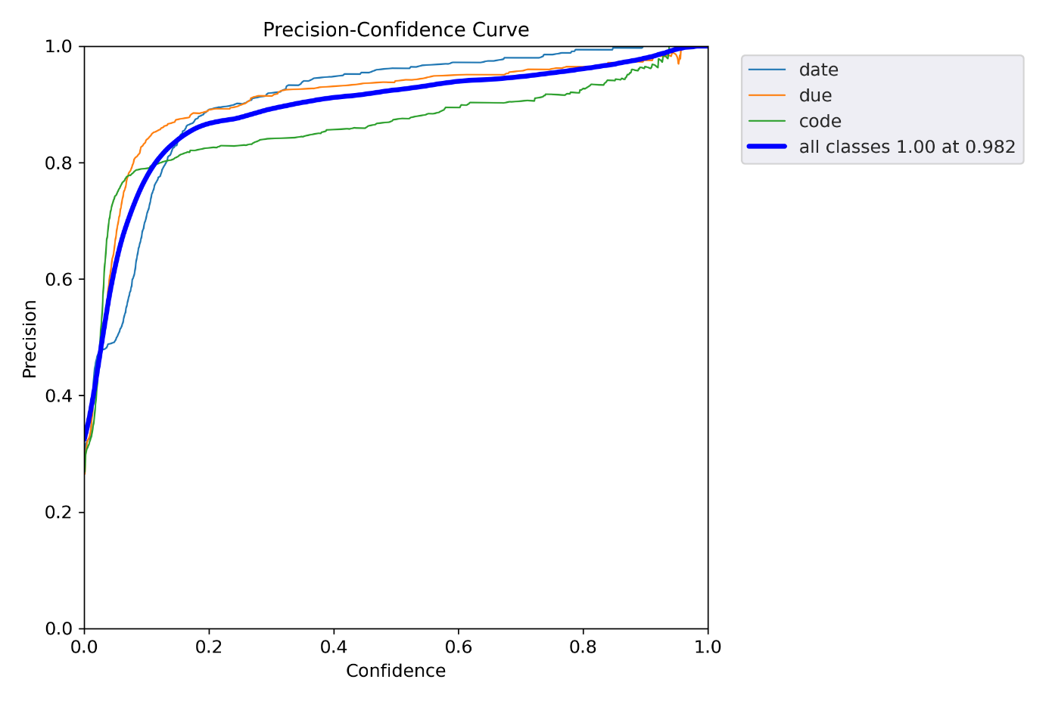

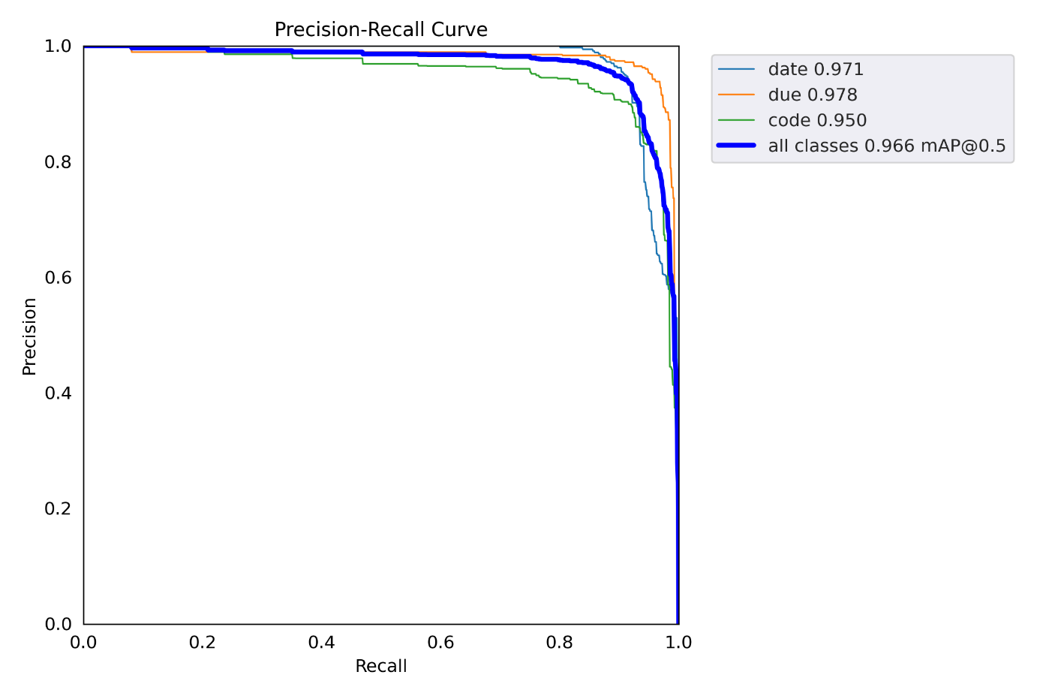

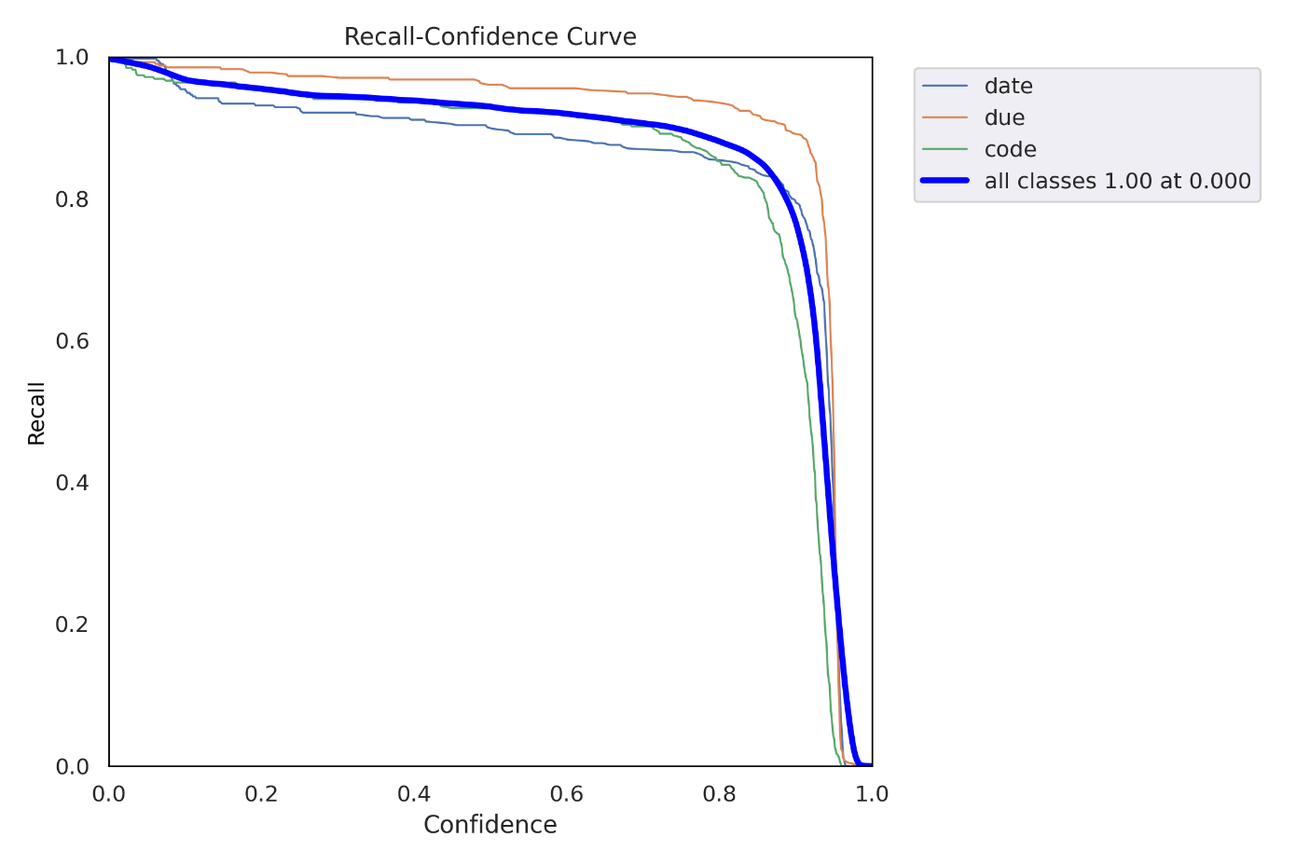

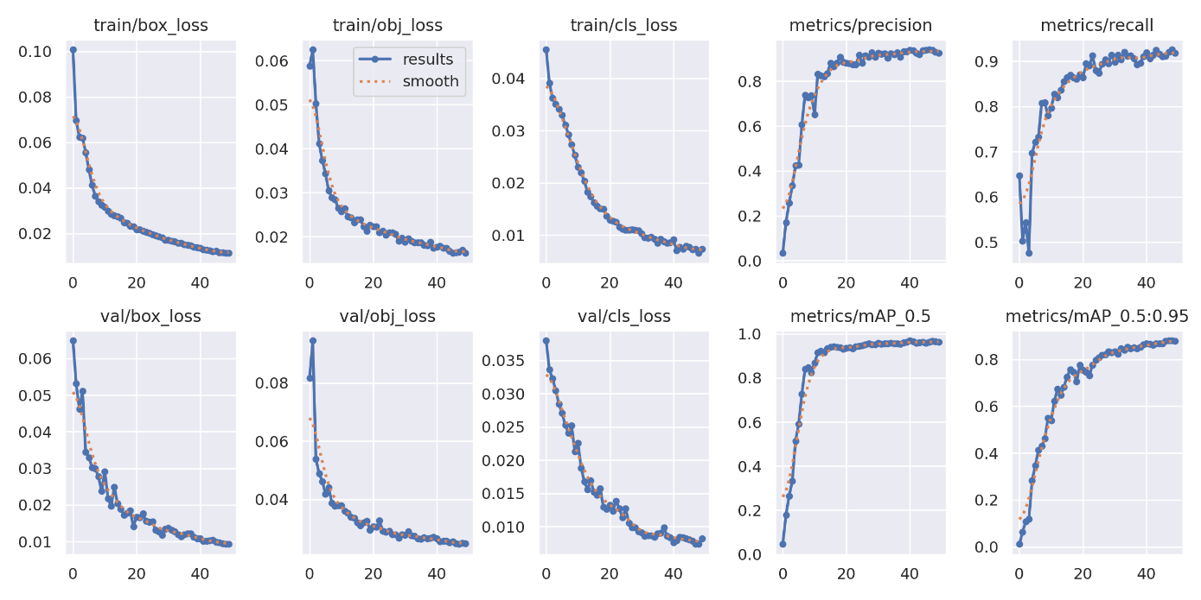

**Train batch’s**

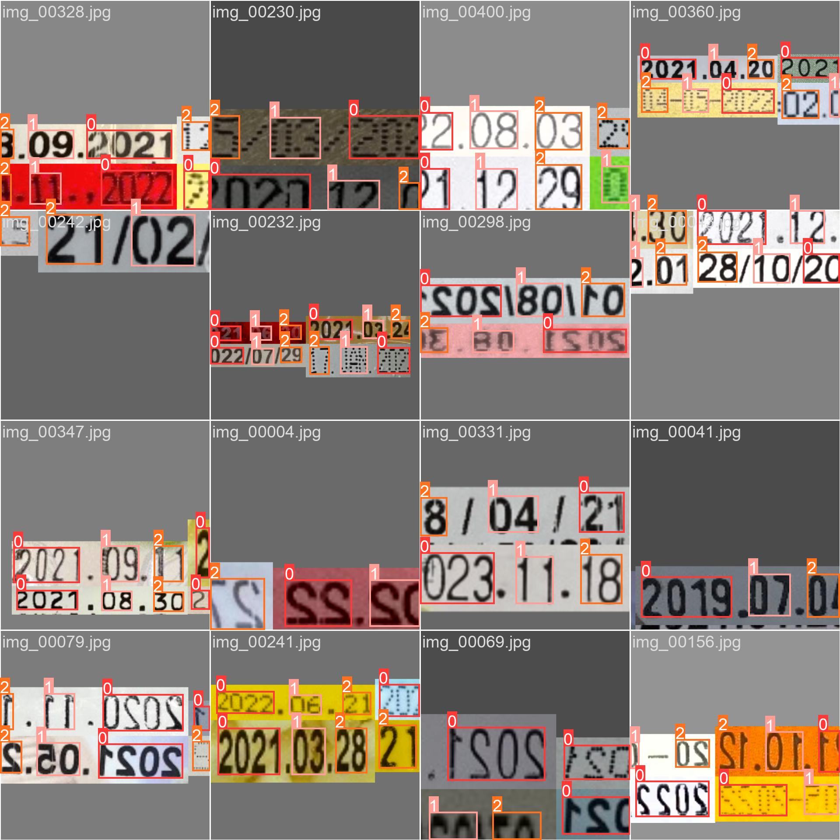

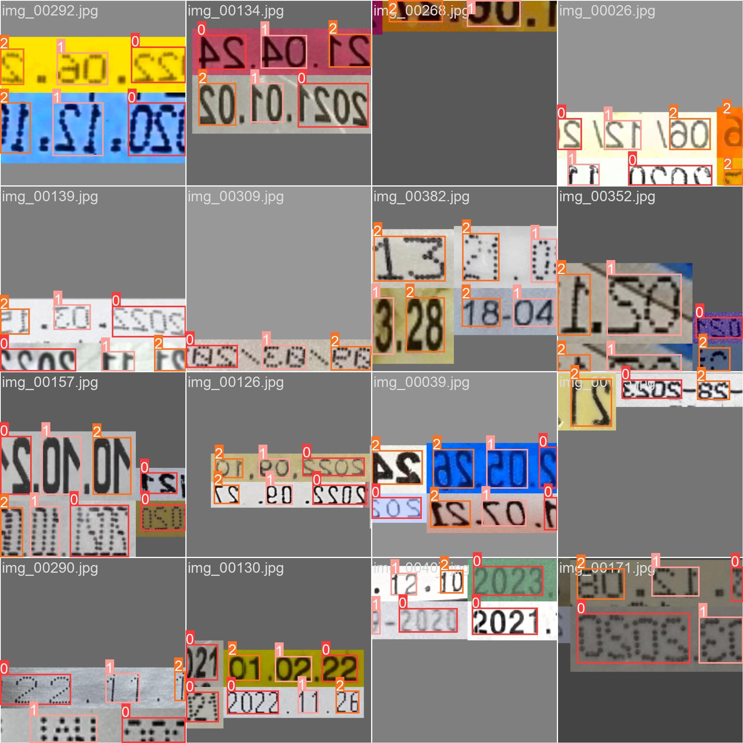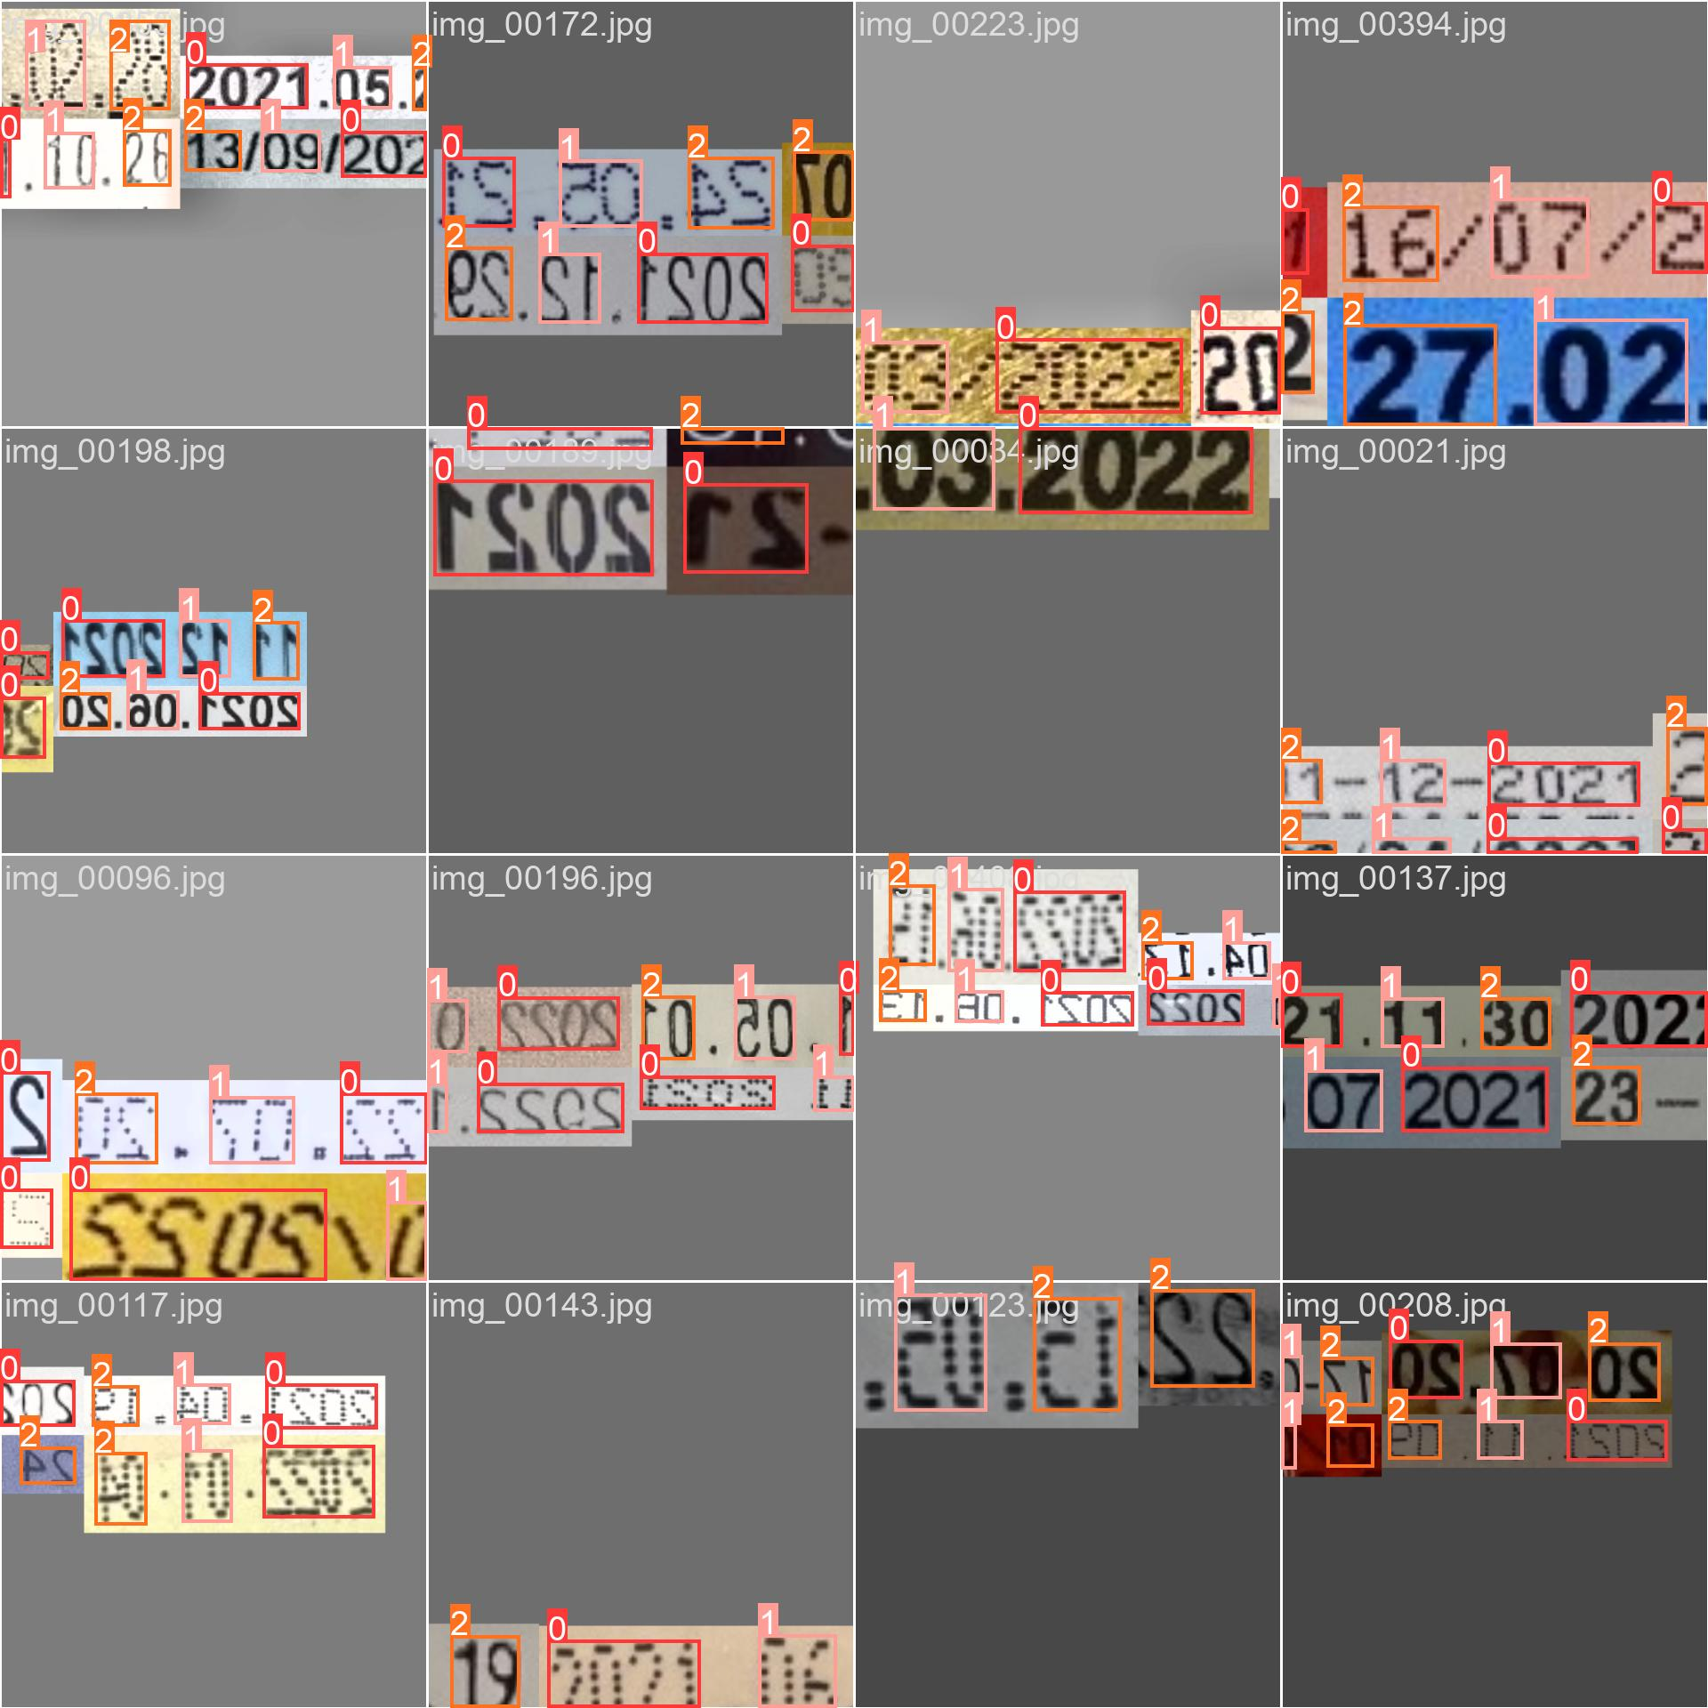

**Val batch’s**



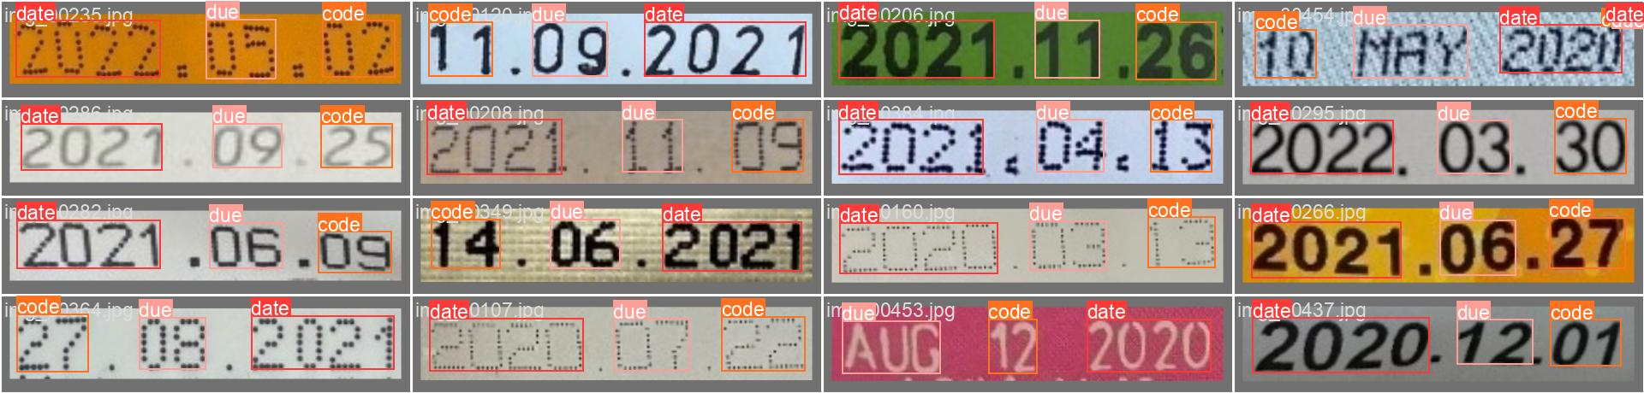



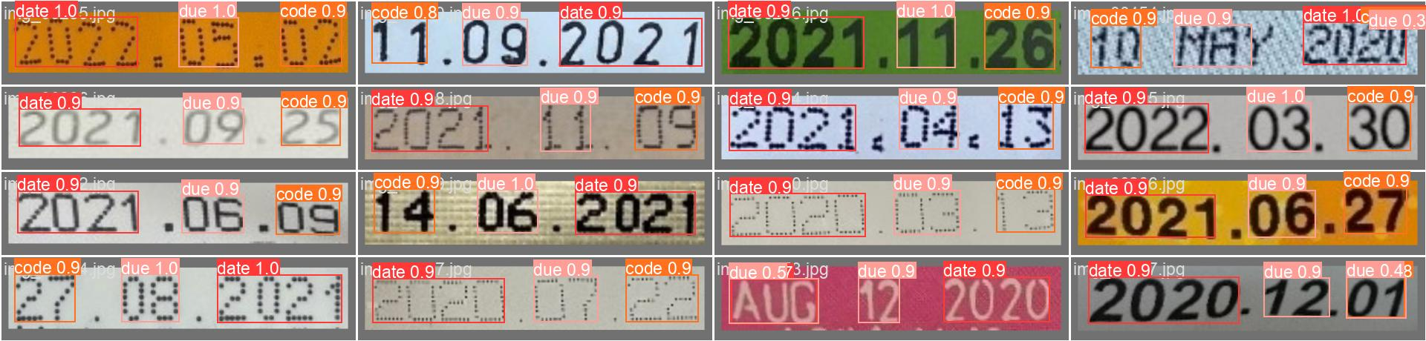

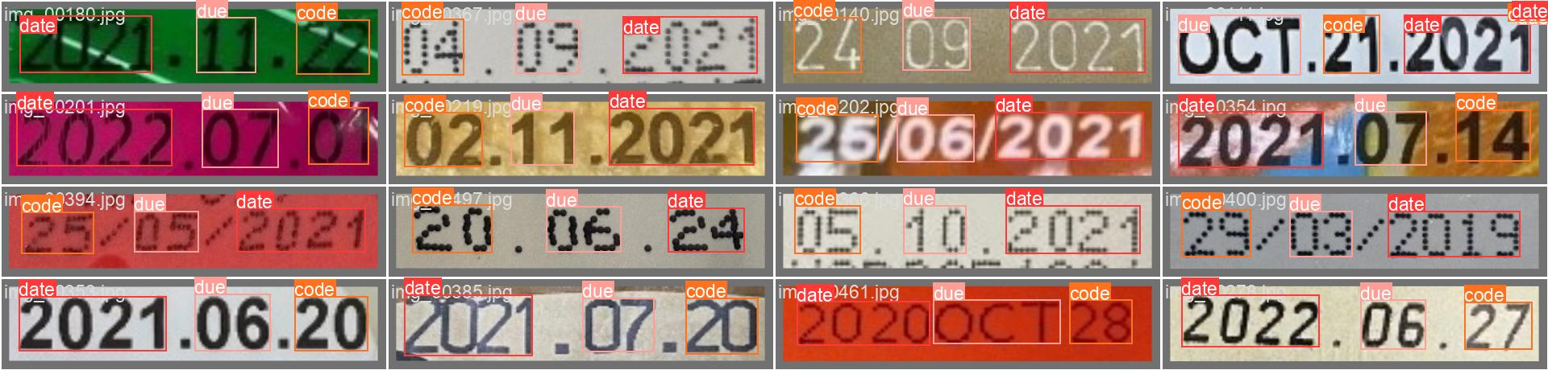

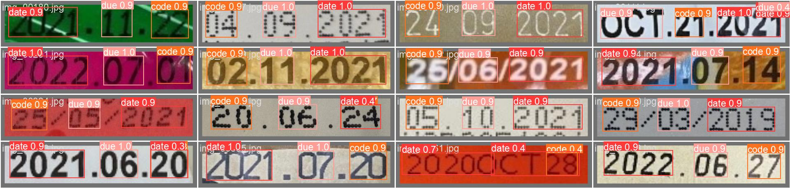

### ****Appendix H: Detailed**** YOLO V8 ****Model Performance Data****

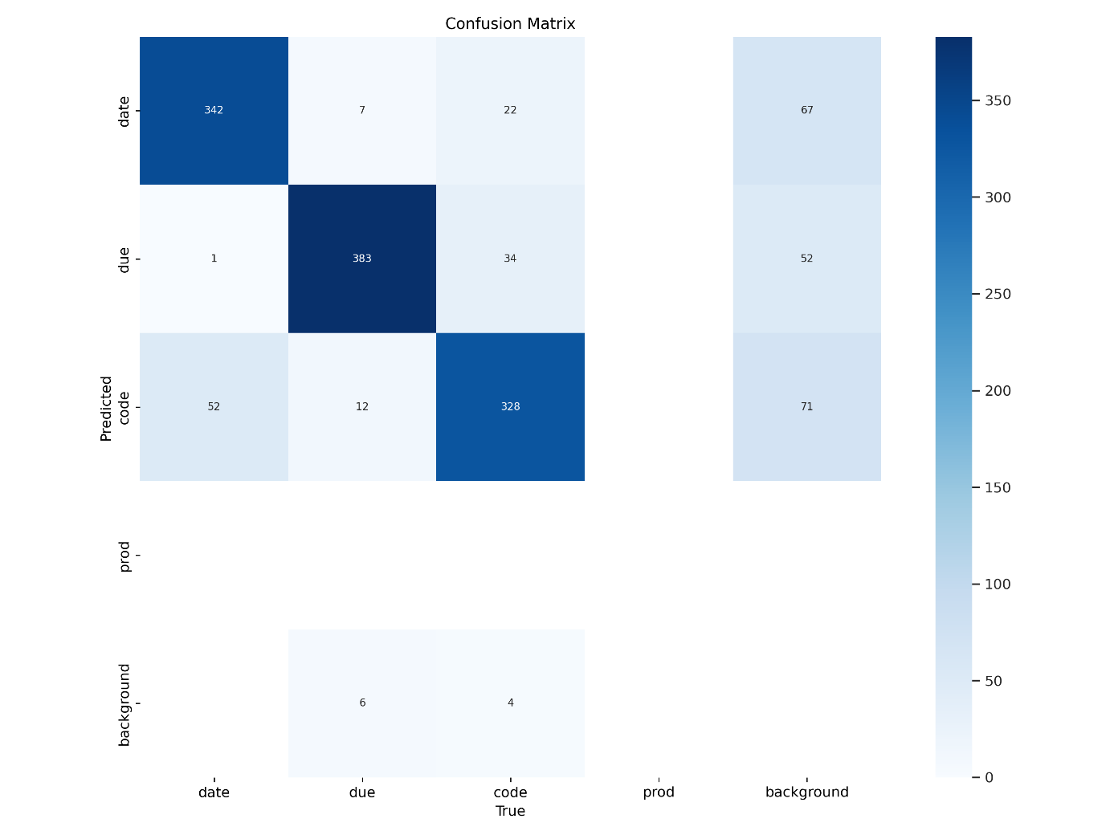

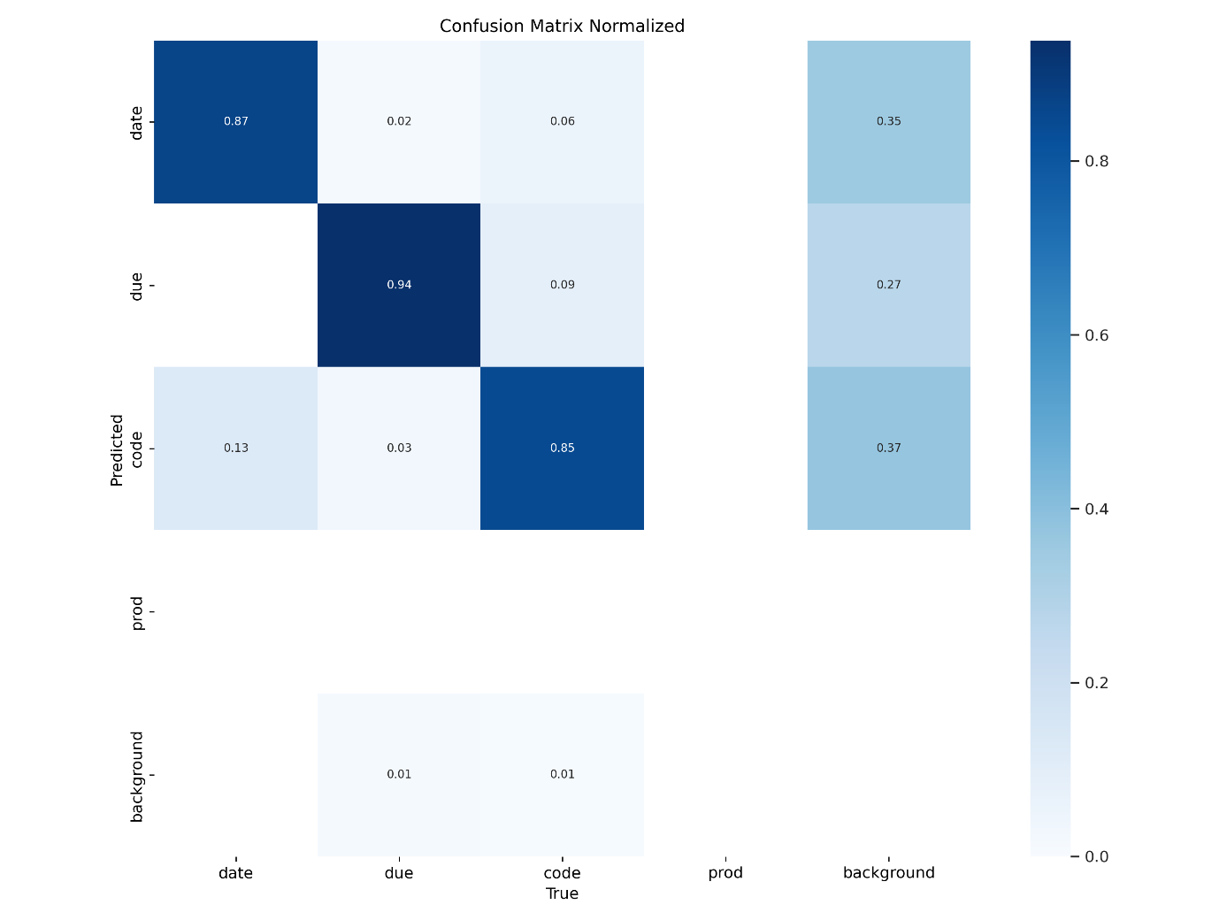

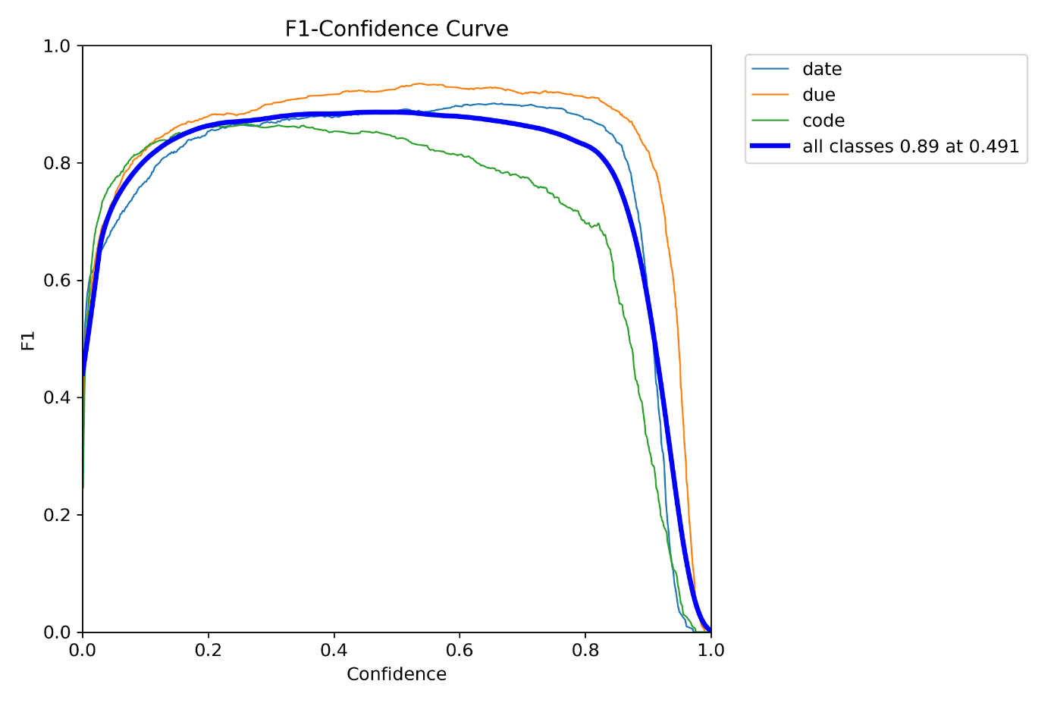

**Labels**

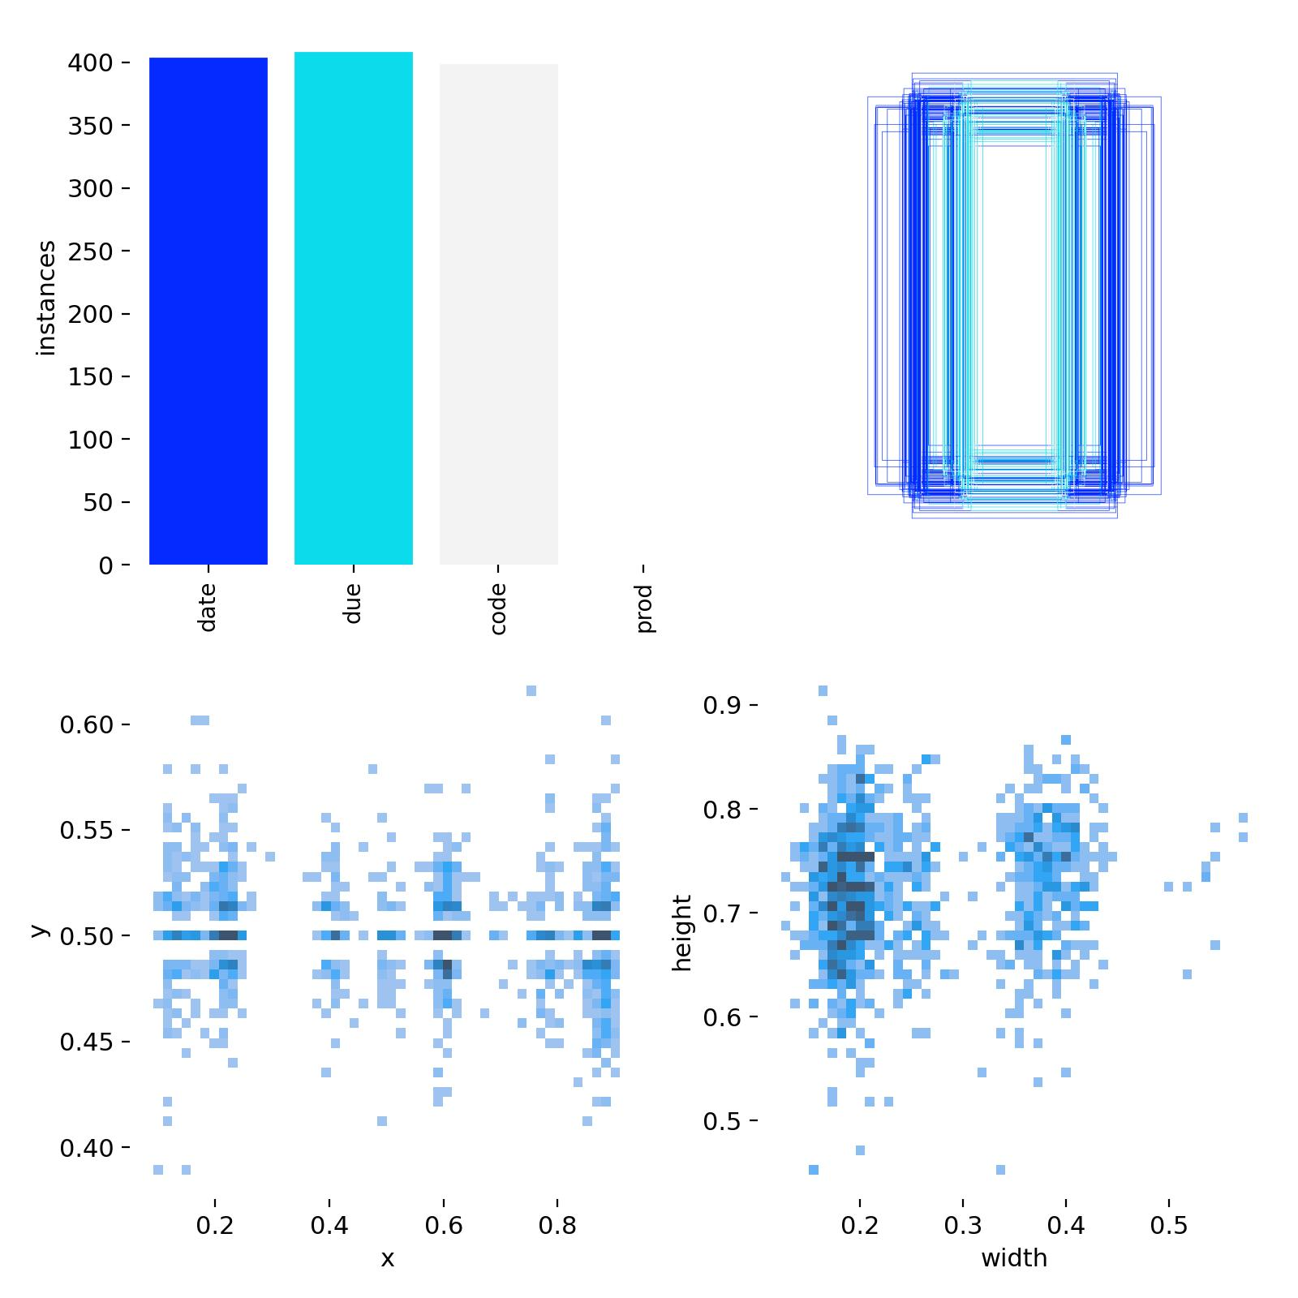

**Labels Correlogram**



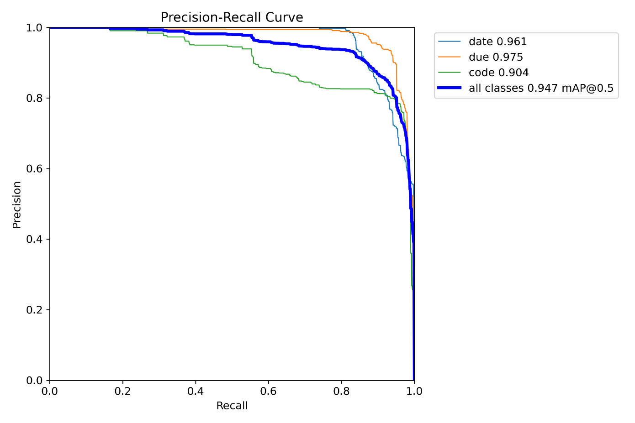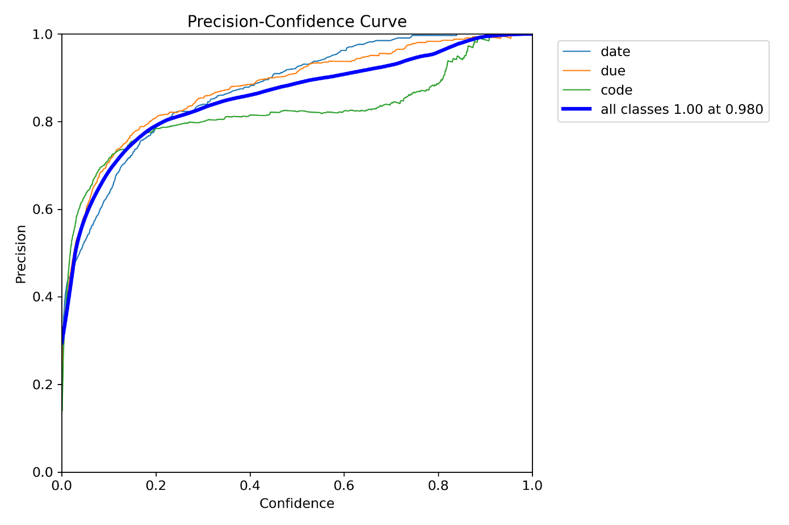

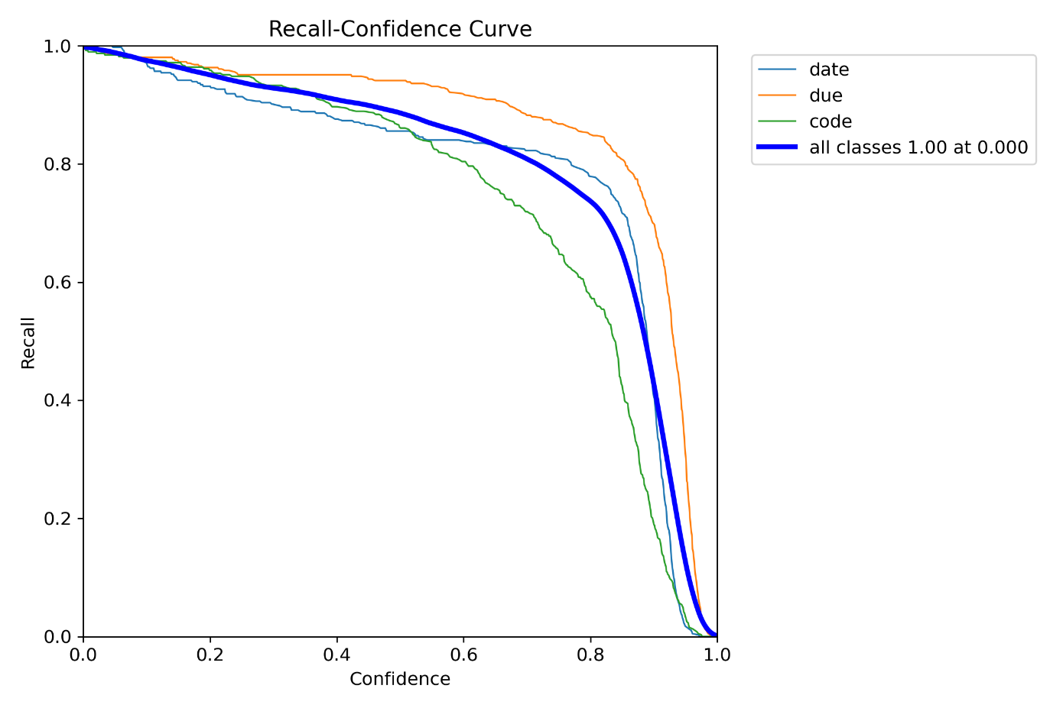

**Results**

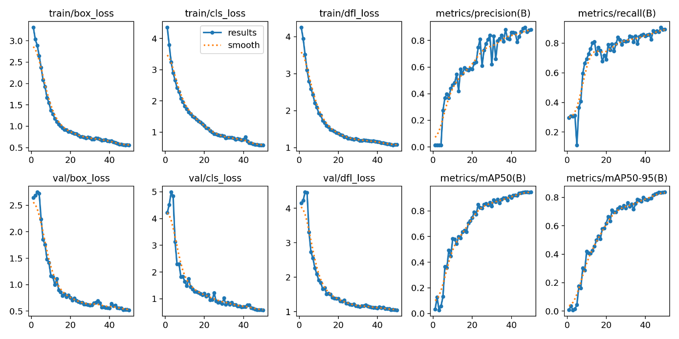

**Train Batch**

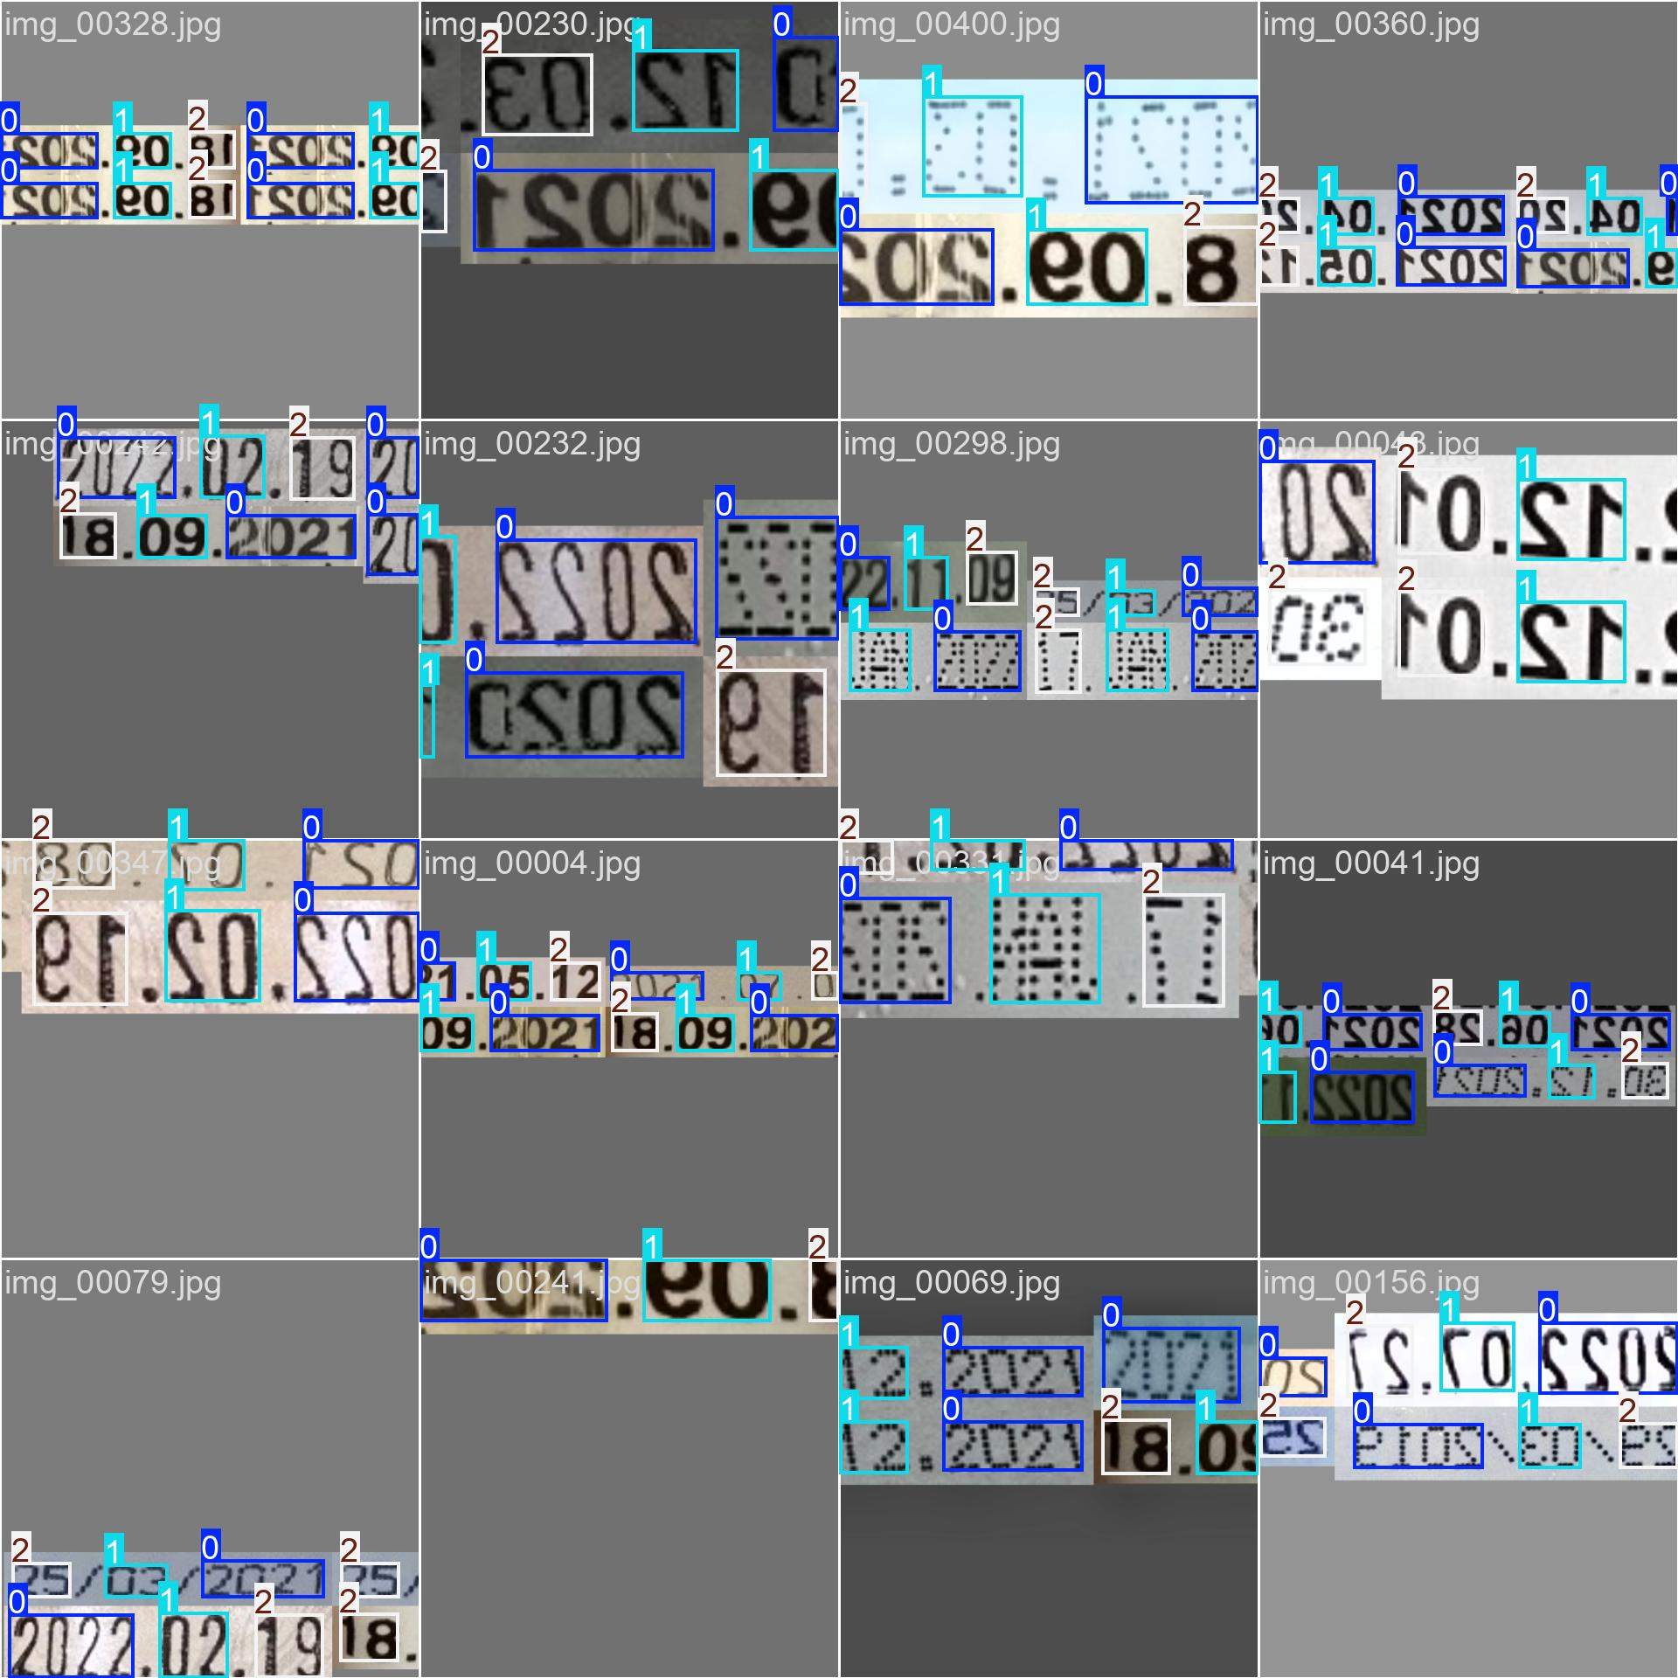

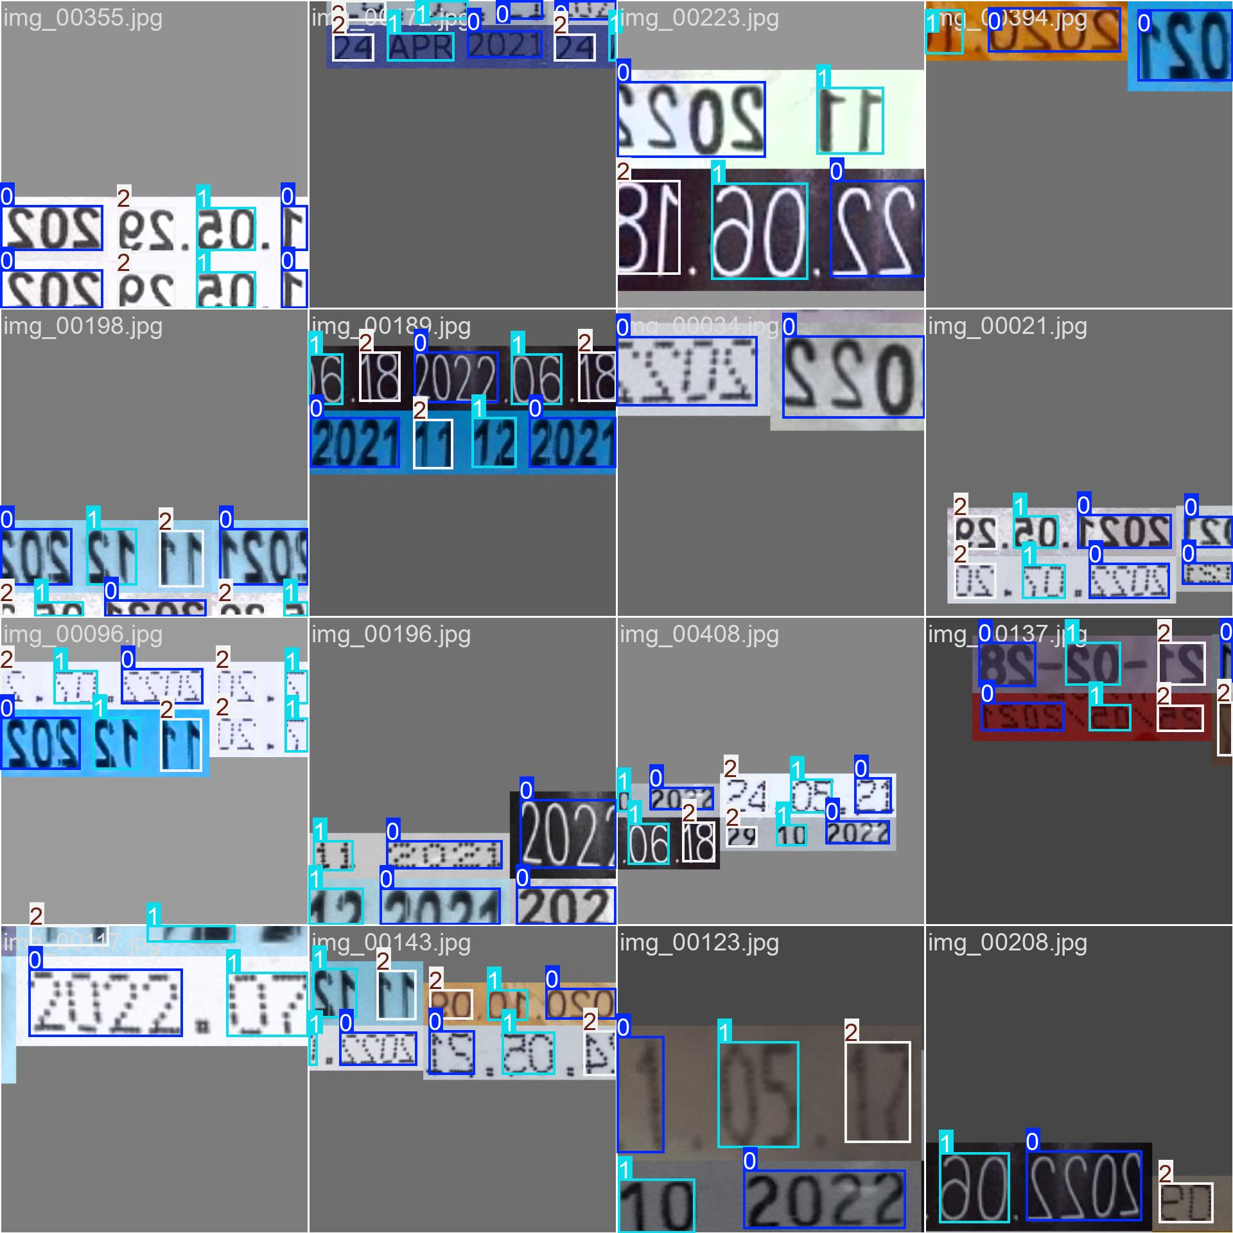

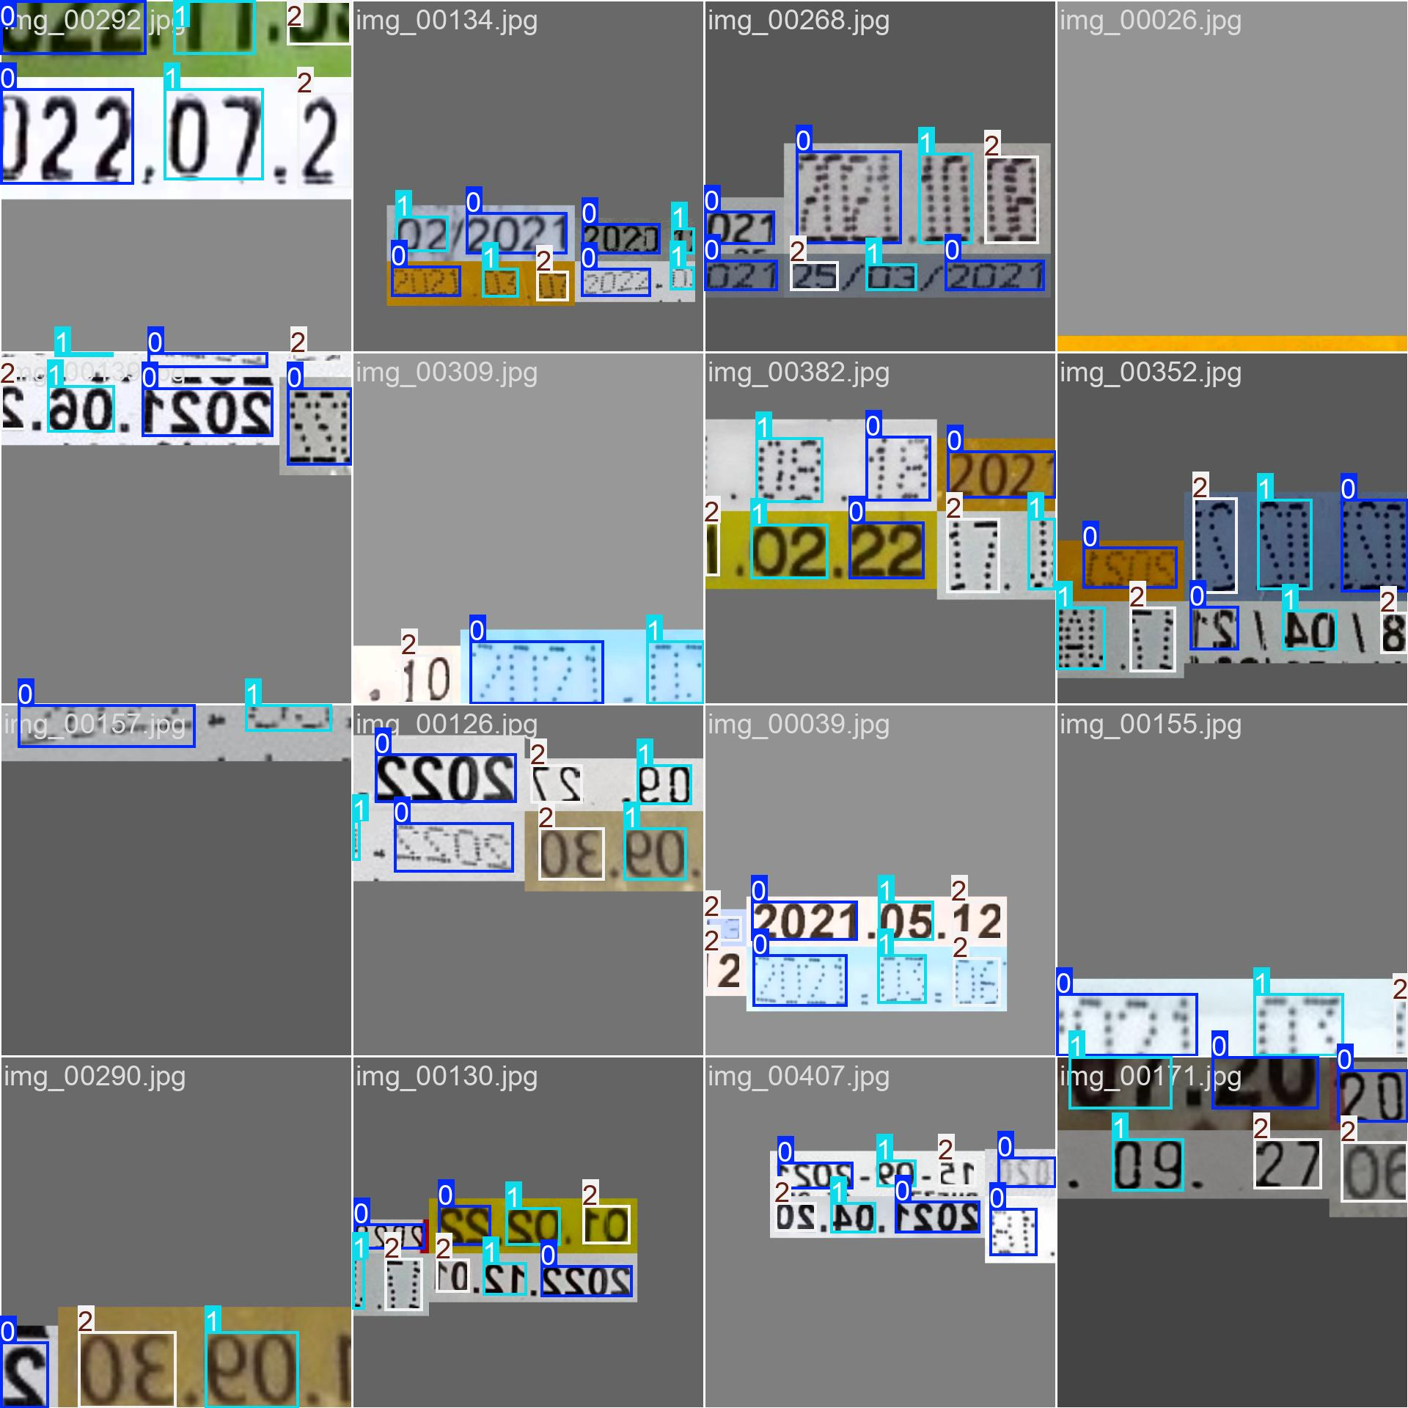

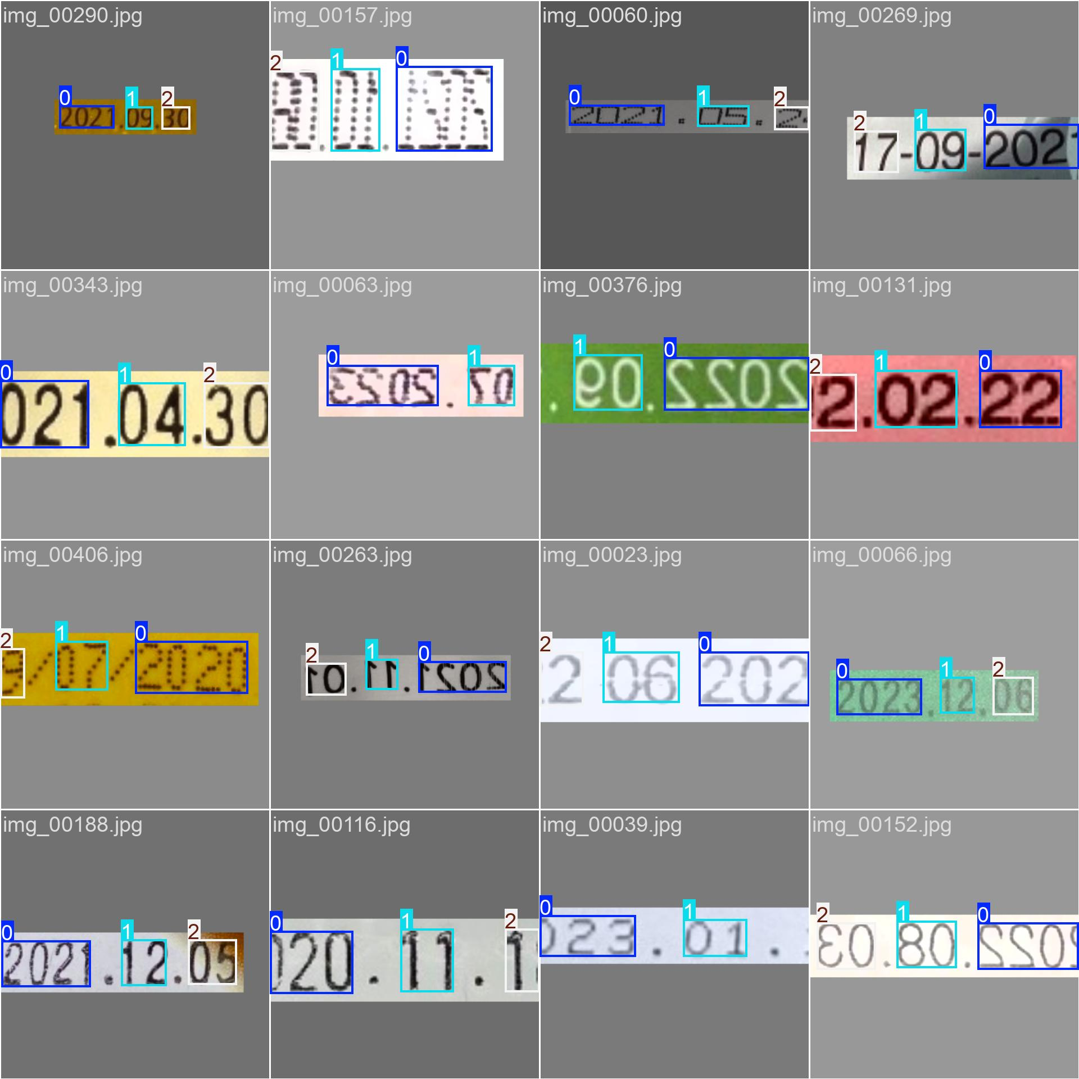

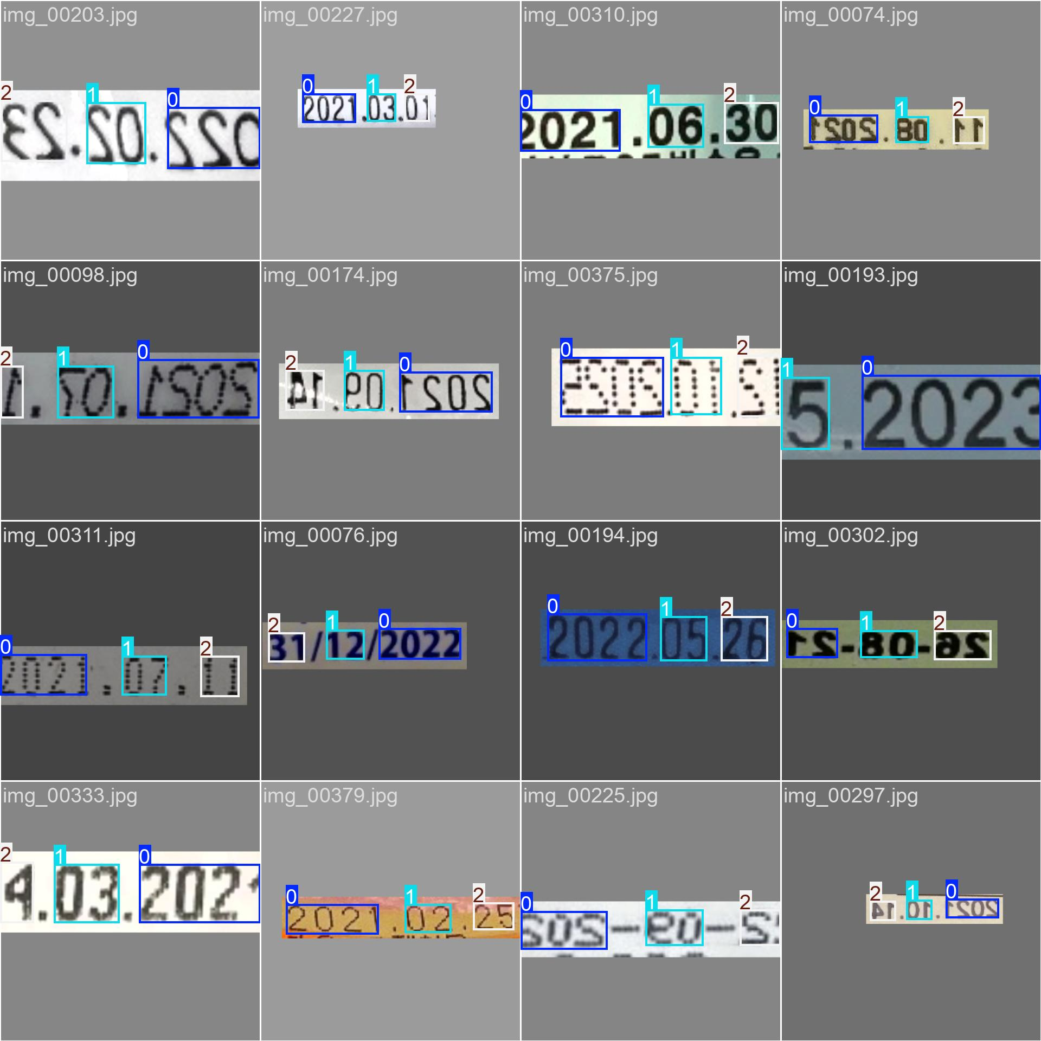

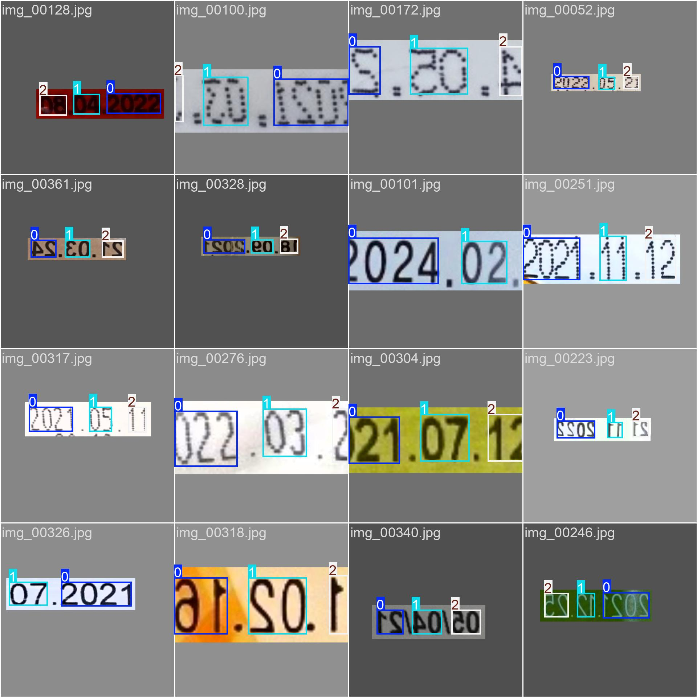

**Val Batch’s**





